AI POWERED MENTAL HEALTH DIAGNOSIS

*Submitted for partial fulfillment of the requirements*

*for the award of*

**BACHELOR OF TECHNOLOGY**

**in**

**COMPUTER SCIENCE ENGINEERING – ARTIFICIAL INTELLIGENCE & MACHINE LEARNING**

by

**Sanala Bala Sree Varsha - 21BQ1A42F5**

**Parasa Hari Sai - 22BQ5A4213**

**Sathiri Vyshnavi - 21BQ1A42F8**

**Karumuru Jahnavi - 22BQ5A4220**

Under the guidance of

**Mr. Md. Sayeed, Assistant Professor**



**DEPARTMENT OF COMPUTER SCIENCE ENGINEERING – ARTIFICIAL INTELLIGENCE & MACHINE LEARNING**

**VASIREDDY VENKATADRI INSTITUTE OF TECHNOLOGY**

Permanently Affiliated to JNTU Kakinada, Approved by AICTE

Accredited by NAAC with ‘A’ Grade, ISO 9001:2008 Certified

NAMBUR (V), PEDAKAKANI (M), GUNTUR – 522 508

Tel no: 0863-2118036, url: [www.vvitguntur.com](http://www.vvitguntur.com)

April 2025



**VASIREDDY VENKATADRI INSTITUTE OF TECHNOLOGY**

Permanently Affiliated to JNTUK, Kakinada, Approved by AICTE

Accredited by NAAC with ‘A’ Grade, ISO 9001:20008 Certified

Nambur, Pedakakani (M), Guntur (Gt) -522508

**DEPARTMENT OF COMPUTER SCIENCE ENGINEERING - ARTIFICIAL INTELLIGENCE & MACHINE LEARNING**

**CERTIFICATE**

This is to certify that this **Project Report** is the bonafide work of **Ms. Sanala Bala Sree Varsha, Mr. Parasa Hari Sai, Ms. Sathiri Vyshnavi, Ms. Karumuru Jahnavi**, bearing Reg. No. **21BQ1A42F5, 22BQ5A4213, 21BQ1A42F8, 22BQ5A4220** respectively who had carried out the project entitled **“AI Powered Mental Health Diagnosis"** under our supervision.

**Project Guide Head of the Department**

(Mr. Md. Sayeed, Assistant Professor) (Dr. K. Suresh Babu, Professor)

**Submitted for Viva voce Examination held on ____________________________**

**Internal Examiner External Examiner**

**DECLARATION**

We, Ms. Sanala Bala Sree Varsha, Mr. Parasa Hari Sai, Ms. Sathiri Vyshnavi, Ms. Karumuru Jahnavi, hereby declare that the Project Report entitled **“AI Powered Mental Health Diagnosis System”** done by us under the guidance of Mr. Md. Sayeed, Assistant Professor, CSE-Artificial Intelligence & Machine Learning at Vasireddy Venkatadri Institute of Technology is submitted for partial fulfillment of the requirements for the award of Bachelor of Technology in Computer Science Engineering - Artificial Intelligence & Machine Learning. The results embodied in this report have not been submitted to any other University for the award of any degree.

DATE :

PLACE : Nambur

**SIGNATURE OF THE CANDIDATE (S)**

Sanala Bala Sree Varsha,

Parasa Hari Sai,

Sathiri Vyshnavi,

Karumuru Jahnvai.

**ACKNOWLEDGEMENT**

We take this opportunity to express my deepest gratitude and appreciation to all those people who made this project work easier with words of encouragement, motivation, discipline, and faith by offering different places to look to expand my ideas and helped me towards the successful completion of this project work.

First and foremost, we express my deep gratitude to **Mr. Vasireddy Vidya Sagar**, Chairman, Vasireddy Venkatadri Institute of Technology for providing necessary facilities throughout the B.Tech program.

We express my sincere thanks to **Dr. Y. Mallikarjuna Reddy**, Principal, Vasireddy Venkatadri Institute of Technology for his constant support and cooperation throughout the B.Tech program.

We express my sincere gratitude to **Dr. K. Suresh Babu**, Professor & HOD, Computer Science Engineering - Artificial Intelligence & Machine Learning, Vasireddy Venkatadri Institute of Technology for his constant encouragement, motivation and faith by offering different places to look to expand my ideas.

We would like to express my sincere gratefulness to our Guide **Mr. Md. Sayeed**, Assistant Professor, Computer Science Engineering - Artificial Intelligence & Machine Learningfor her insightful advice, motivating suggestions, invaluable guidance, help and support in successful completion of this project.

We would like to express our sincere heartfelt thanks to our Project Coordinator **Mrs. K. Deepika**, Assistant Professor, Computer Science Engineering - Artificial Intelligence & Machine Learning for his valuable advices, motivating suggestions, moral support, help and coordination among us in successful completion of this project.

We would like to take this opportunity to express my thanks to the **Teaching and Non-Teaching** Staff in the Department of Computer Science Engineering - Artificial Intelligence & Machine Learning, VVIT for their invaluable help and support.

**Sanala Bala Sree Varsha**

**Parasa Hari Sai**

**Sathiri Vyshnavi**

**Karumuru Jahnavi**

**TABLE OF CONTENTS**

|  |  |  |  |  |  |  |  |  |  |  |  |  |  |  |  |  |  |  |  |  |  |  |  |  |
| --- | --- | --- | --- | --- | --- | --- | --- | --- | --- | --- | --- | --- | --- | --- | --- | --- | --- | --- | --- | --- | --- | --- | --- | --- |
| **CH No** | **Title** | | | | | | | | | | | **Page No** | | | | | | |  | | | | | |
|  | Contents | | | | | | | | | | | i | | | | | | |  | | | | | |
|  | List of Figures | | | | | | | | | | | iv | | | | | | |  | | | | | |
|  | List of Tables | | | | | | | | | | | v | | | | | | |  | | | | | |
|  | Nomenclature | | | | | | | | | | | vi | | | | | | |  | | | | | |
|  | Abstract | | | | | | | | | | | vii | | | | | | |  | | | | | |
| 1 | | INTRODUCTION | | | | | | | | | | | | | 1 | | | | | | | | |
| 1.1 | | Background of the Project | | | | | | | 1 | | | | | | | | | | |
| 1.2 | | Problem Statement | | | | | | | 1 | | | | | | | | | | |
| 1.3 | | Objectives of the Project | | | | | | | 2 | | | | | | | | | | |
| 1.4 | | Scope of the Project | | | | | | | 3 | | | | | | | | | | |
| 1.5 | | Methodology Overview | | | | | | | 5 | | | | | | | | | | |
| 1.6 | | Organization of the Report | | | | | | | 7 | | | | | | | | | | |
| 2 | | LITERATURE REVIEW | | | | | | | | 9 | | | | | | | | |
| 2.1 | | Previous Research and Related Work | | | | | | 9 | | | | | | | | | | | |
| 2.2 | | Existing Solutions and Their Limitations | | | | | | 10 | | | | | | | | | | | |
| 2.3 | | Gap Analysis | | | | | | 12 | | | | | | | | | | | |
| 2.4 | | Relevance of the Project | | | | | | 14 | | | | | | | | | | | |
| 3 | | SYSTEM ANALYSIS | | | | | | | | | | | | 16 | | | |
| 3.1 | | Requirement Analysis | | | | | | | | 16 | | | | | | | | | |
| 3.1.1 | | | Functional Requirements | | | | | | | | | 16 | | | | | | | | |
| 3.1.2 | | | Non-functional Requirements | | | | | | | | | 18 | | | | | | | | |
| 3.2 | | Feasibility Study | | | | | | | | 20 | | | | | | | | | |
| 3.2.1 | | | Technical Feasibility | | | | | | | | | 21 | | | | | | | | |
| 3.2.2 | | | Economic Feasibility | | | | | | | | | 21 | | | | | | | | |
| 3.2.3 | | | Operational Feasibility | | | | | | | | | 22 | | | | | | | | |
| 3.3 | | Proposed System Overview | | | | | | | | 23 | | | | | | | | | |
| 4 | | SYSTEM DESIGN | | | | | | | | 26 | | | | | | |
| 4.1 | | System Architecture | | | | | | | | | | | 26 | | | | | | |
| 4.2 | | Block Diagram | | | | | | | | | | | 28 | | | | | | |
| 4.3 | | Data Flow Diagrams (DFD) | | | | | | | | | | | 29 | | | | | | |
| 4.4 | | UML Diagrams | | | | | | | | | | | 31 | | | | | | |
| 4.4.1 | | | Use Case Diagram | | | | | | | | | 32 | | | | | | | | |
| 4.4.2 | | | Class Diagram | | | | | | | | | 33 | | | | | | | | |
| 4.4.3 | | | Sequence Diagram | | | | | | | | | 34 | | | | | | | | |
| 4.4.4 | | | Activity Diagram | | | | | | | | | 35 | | | | | | | | |
| 4.5 | | Database Design | | | | | | | | 36 | | | | | | | | | |
| 4.5.1 | | | | ER Diagram | | | | | | | | 37 | | | | | | | | |
| 4.5.2 | | | | Schema Design | | | | | | | | 38 | | | | | | | | |
| 5 | | IMPLEMENTATION | | | | | | | | 39 | | | | | | | | | | | |
| 5.1 | | Programming Languages and Technologies Used | | | | | | | | | | | 39 | | | | | | |
| 5.2 | | Development Tools and Environments | | | | | | | | | | | 41 | | | | | | |
| 5.3 | | Module-Wise Implementation Details | | | | | | | | | | | 43 | | | | | | |
| 5.4 | | Algorithms and Logic Used | | | | | | | | | | | 47 | | | | | | |
| 6 | | TESTING AND RESULTS | | | | | | | | | | | | | | 48 | |
| 6.1 | | | Testing Methodologies | | | | | | | 48 | | | | | | | | | |
| 6.1.1 | | | | | Unit Testing | | | | | | | 49 | | | | | | | | |
| 6.1.2 | | | | | Integration Testing | | | | | | | 50 | | | | | | | | |
| 6.1.3 | | | | | System Testing | | | | | | | 50 | | | | | | | | |
| 6.2 | | | Test Cases and Reports | | | | | | | 52 | | | | | | | | | |
| 6.3 | | | Performance Evaluation | | | | | | | 55 | | | | | | | | | |
| 6.4 | | | Screenshots of Application Output | | | | | | | 56 | | | | | | | | | |
| 6.5 | | | Deployment | | | | | | | 60 | | | | | | | | | |
| 6.5.1 | | | | | Deployment Architecture | | | | | | | 60 | | | | | | | | |
| 6.5.2 | | | | | Tools Used | | | | | | | 61 | | | | | | | | |
| 6.5.3 | | | | | Challenges Faced | | | | | | | 61 | | | | | | | | |
| 7 | | CONCLUSION AND FUTURE WORK | | | | | | | | 62 | | | | | | | | | | |
| 7.1 | | | Summary of Findings | | | | | | | | | | 62 | | | | | | |
| 7.2 | | | Key Achievements and Contributions | | | | | | | | | | 62 | | | | | | |
| 7.3 | | | Challenges Faced | | | | | | | | | | 63 | | | | | | |
| 7.4 | | | Future Scope and Improvements | | | | | | | | | | 64 | | | | | | |
| 8 | | REFERENCES | | | | | | | | | | | | 66 | | | | |
|  | | APPENDIXPublication Certificate | | | | | | | | | | | | 69 | | | | |

# LIST OF FIGURES

| Figure No. | Figure Name | Page No. |
| --- | --- | --- |
| Figure 1.4.1 | Project Flow Overview | 4 |
| Figure 1.5.1 | Data Collection Process | 6 |
| Figure 2.2.1 | Comparative Table of Existing Mental Health Diagnosis Tools | 11 |
| Figure 2.3.1 | Gap in Current Mental Health Diagnosis Systems | 13 |
| Figure 3.1.1.1 | Functional Requirements of the System | 16 |
| Figure 3.2.1 | System Feasibility Analysis | 20 |
| Figure 3.3.1 | Proposed System Architecture | 23 |
| Figure 4.1.1 | System Architecture Diagram | 26 |
| Figure 4.2.1 | Block Diagram of the System | 28 |
| Figure 4.3.1 | Data Flow Diagram (DFD) - Level 0 | 29 |
| Figure 4.3.2 | Data Flow Diagram (DFD) - Level 1 | 31 |
| Figure 4.4.1.1 | Use Case Diagram | 32 |
| Figure 4.4.2.1 | Class Diagram | 33 |
| Figure 4.4.3.1 | Sequence Diagram | 34 |
| Figure 4.4.4.1 | Activity Diagram | 36 |
| Figure 4.5.1.1 | ER Diagram | 37 |
| Figure 4.5.2.1 | Database Schema Design | 38 |
| Figure 5.1.1 | Programming Languages and Technologies Stack | 39 |
| Figure 5.2.1 | System Flow | 42 |
| Figure 5.3.1 | Snippet of Model Implementation | 44 |
| Figure 5.4.1 | Flowchart for Model Training and Prediction | 48 |
| Figure 6.1.1 | Testing Methodology Flowchart | 49 |
| Figure 6.1.3.1 | Performance Comparison Chart | 51 |
| Figure 6.2.1 | Sample Test Case Results | 54 |
| Figure 6.4.1 | Screenshots of Application Output | 57-59 |
| Figure 6.5.1.1 | Deployment Architecture Diagram | 60 |

# LIST OF TABLES

| **Table No.** | **Table Name** | | **Page No.** |
| --- | --- | --- | --- |
| Table 3.1.1.1 | Functional Requirements of the System | 18 | |
| Table 3.2.3.1 | Feasibility Study Summary (Technical, Economic, Operational) | 22 | |
| Table 5.1.1 | Technology Stack Overview (List of programming languages, libraries, and tools used) | 40 | |
| TABLE 6.2.1 | Test Reports | 55 | |

# NOMENCLATURE

| **Acronym** | **Full Form** | **Description** |
| --- | --- | --- |
| **AI** | Artificial Intelligence | Simulation of human intelligence in machines to perform tasks such as diagnosis and prediction. |
| **ML** | Machine Learning | A subset of AI that enables systems to learn from data and improve their performance over time without explicit programming. |
| **NLP** | Natural Language Processing | A field of AI that enables machines to understand, interpret, and respond to human language, used in this project for chatbot functionalities. |
| **EDA** | Exploratory Data Analysis | A process of analyzing datasets to summarize their main characteristics, often using visual methods like graphs and charts. |
| **CSV** | Comma-Separated Values | A file format used for storing tabular data in plain text, often used for importing and exporting datasets in this project. |
| **API** | Application Programming Interface | A set of functions that allow software applications to communicate with each other, used in this project for chatbot functionalities. |
| **EC2** | Elastic Compute Cloud | A web service provided by AWS for scalable computing capacity in the cloud, used for deploying the AI model and hosting the application. |
| **OTP** | One-Time Password | A temporary, single-use password for secure user authentication, implemented in the system for user registration. |
| **F1-Score** | F1-Score | A performance metric used to evaluate classification models, providing a balance between precision and recall. |
| **Confusion Matrix** | Confusion Matrix | A table used to evaluate the performance of classification models by showing the true positives, false positives, true negatives, and false negatives. |
| **Dialogflow** | Google Dialogflow | A cloud-based NLP service used to build conversational interfaces like chatbots, integrated into this project to process user inputs and provide suggestions. |
| **Perplexity API** | Perplexity API | A chatbot integration providing real-time assistance for relaxation techniques and mood management through natural language understanding. |

**ABSTRACT**

Mental health challenges are increasingly prevalent in today's fast-paced, high-pressure environments, particularly among professionals. The **AI-BASED MENTAL HEALTH DIAGNOSIS** system addresses this growing concern by leveraging **machine learning algorithms** to predict mental health conditions based on various inputs such as user-reported symptoms, lifestyle choices, and work-related stress. The system processes both **structured and unstructured data**, including **behavioral patterns** and **historical data**, to provide a comprehensive mental health assessment.

Incorporating **Exploratory Data Analysis (EDA)**, the system identifies significant trends and risk factors, contributing to a more detailed understanding of mental health deterioration. The system uses a variety of machine learning models, including **logistic regression, decision trees, random forests**, and **ensemble methods**, to predict mental health states. **Natural language processing (NLP)**, powered by **Google Dialogflow**, enhances chatbot interactions, allowing real-time feedback and guidance.

The platform offers users **personalized interventions**, including relaxation techniques, music suggestions, and yoga practices, tailored to their specific mental health needs. An **interactive dashboard** allows users to track their mental health over time, view reports, and access AI-driven insights. By providing **automated alerts** and **real-time suggestions**, the system not only detects early signs of distress but also promotes overall mental well-being. Deployed using **AWS EC2**, the system is scalable, ensuring reliable support for users.

This AI-driven platform represents a significant step toward enhancing **mental health awareness** and providing **proactive support** to individuals, with future improvements planned for expanding datasets, integrating real-time data, and refining model predictions.

# Chapter 1: Introduction

# 1.1 Background of the Project

Mental health has become a crucial aspect of overall well-being, particularly in high-stress sectors like technology, where long working hours and tight deadlines contribute to conditions such as anxiety, depression, and burnout. These mental health issues can negatively affect productivity, creativity, and quality of life, requiring more accessible solutions. Traditional diagnosis methods, relying on in-person interactions, can be time-consuming, costly, and stigmatizing, highlighting the need for scalable and efficient alternatives.

The "AI BASED MENTAL HEALTH DIAGNOSIS" project addresses these challenges by leveraging AI and Machine Learning (ML). It uses Natural Language Processing (NLP) to interpret user inputs and predict mental health conditions through models like logistic regression, decision trees, random forests, and bagging classifiers. The system also offers personalized suggestions for managing mental well-being, such as relaxation techniques, yoga, and music recommendations. Hosted on AWS EC2, the system provides scalability, real-time feedback, and easy access, empowering users, especially in high-stress industries, to take control of their mental health.

# 1.2 Problem Statement

Mental health issues have become increasingly prevalent in high-pressure environments like the tech industry, where demands, deadlines, and long hours contribute to stress, anxiety, and burnout. Unfortunately, stigma surrounding mental health prevents many from seeking help, and traditional assessments can be costly, intimidating, and time-consuming. These consultations are often unavailable when needed, leading to delays in diagnosis and treatment, worsening the condition.

The "AI BASED MENTAL HEALTH DIAGNOSIS" project aims to offer an automated, non-intrusive solution that uses AI and ML models to provide real-time mental health feedback. The system allows users to identify early signs of distress and receive personalized suggestions for managing their well-being. It integrates a Google Dialogflow-powered chatbot for interactive conversations, making mental health diagnosis accessible, efficient, and scalable. This proactive approach reduces the stigma of seeking help, empowering individuals to manage their mental health without fear of judgment.

# 1.3 Objectives of the Project

The primary goal of the "AI BASED MENTAL HEALTH DIAGNOSIS" project is to create an accessible, automated system that diagnoses mental health conditions using AI and ML techniques. Specifically targeting high-stress environments such as the tech industry, the system aims to detect early signs of mental health issues, including stress, anxiety, and depression. This will be achieved through predictive models that use machine learning algorithms like logistic regression, decision trees, random forests, and bagging classifiers, ensuring accurate and timely diagnosis based on user input. The system will provide users with a comprehensive, real-time evaluation of their mental health and personalized recommendations for improvement.

In addition to predicting mental health conditions, the project will offer personalized suggestions tailored to the user’s emotional state. These suggestions will include relaxation techniques, yoga exercises, and music recommendations, helping users manage their well-being. The integration of an AI-powered chatbot, built using Google Dialogflow, will allow real-time mood analysis through natural language processing (NLP), enabling users to engage interactively with the system. The chatbot will provide personalized actions to improve emotional health, helping users understand and cope with their mental state. This feature aims to make mental health support more accessible, interactive, and immediate.

The project will also include a user-friendly dashboard to track mental health over time, allowing users to monitor progress, identify trends, and address areas needing attention. The system will ensure secure data storage to protect user confidentiality and will incorporate feedback mechanisms to continually improve its accuracy and effectiveness. With deployment on AWS EC2, the system will be scalable, reliable, and accessible from anywhere, ensuring that more people can benefit from it. The project also strives to reduce the stigma surrounding mental health by offering an anonymous, proactive platform that encourages users to address their issues early, ultimately contributing to a healthier work environment and improving productivity, especially for those in high-pressure industries.

# 1.4 Scope of the Project

The "AI BASED MENTAL HEALTH DIAGNOSIS" project seeks to provide a comprehensive and accessible solution for diagnosing and managing mental health conditions, particularly for tech workers in high-stress environments. The system leverages AI and ML techniques to detect mental health issues by analyzing user input. It will offer real-time predictions and personalized suggestions based on factors like mood, stress levels, symptoms, and personal experiences. By using algorithms such as logistic regression, decision trees, and ensemble models, the system will be able to accurately predict conditions like stress, anxiety, and burnout, offering an efficient and timely diagnosis.

In addition to diagnosing mental health conditions, the system will offer personalized recommendations for improving well-being. Once a condition is detected, the system will provide tailored suggestions for relaxation, yoga exercises, music recommendations, and mindfulness practices, addressing the specific needs of the user. These personalized recommendations will help users manage their mental health and prevent the worsening of their conditions. The goal is to provide not only a diagnostic tool but also practical resources that users can easily incorporate into their daily lives to improve their emotional and mental well-being.

1. **User Dashboard for Monitoring and Feedback:**

* A comprehensive dashboard for users to track mental health over time.
* Displays historical data, including past diagnoses, suggestions, and feedback.
* Helps users monitor progress and identify trends in their well-being.

1. **Integration with AI Chatbot for Real-Time Assistance:**

* Google Dialogflow-powered AI chatbot integrated into the system.
* Provides real-time responses to user inputs, assisting with mood analysis.
* Offers personalized suggestions for relaxation and mood management.

Figure 1.4.1 Project Flow Overview

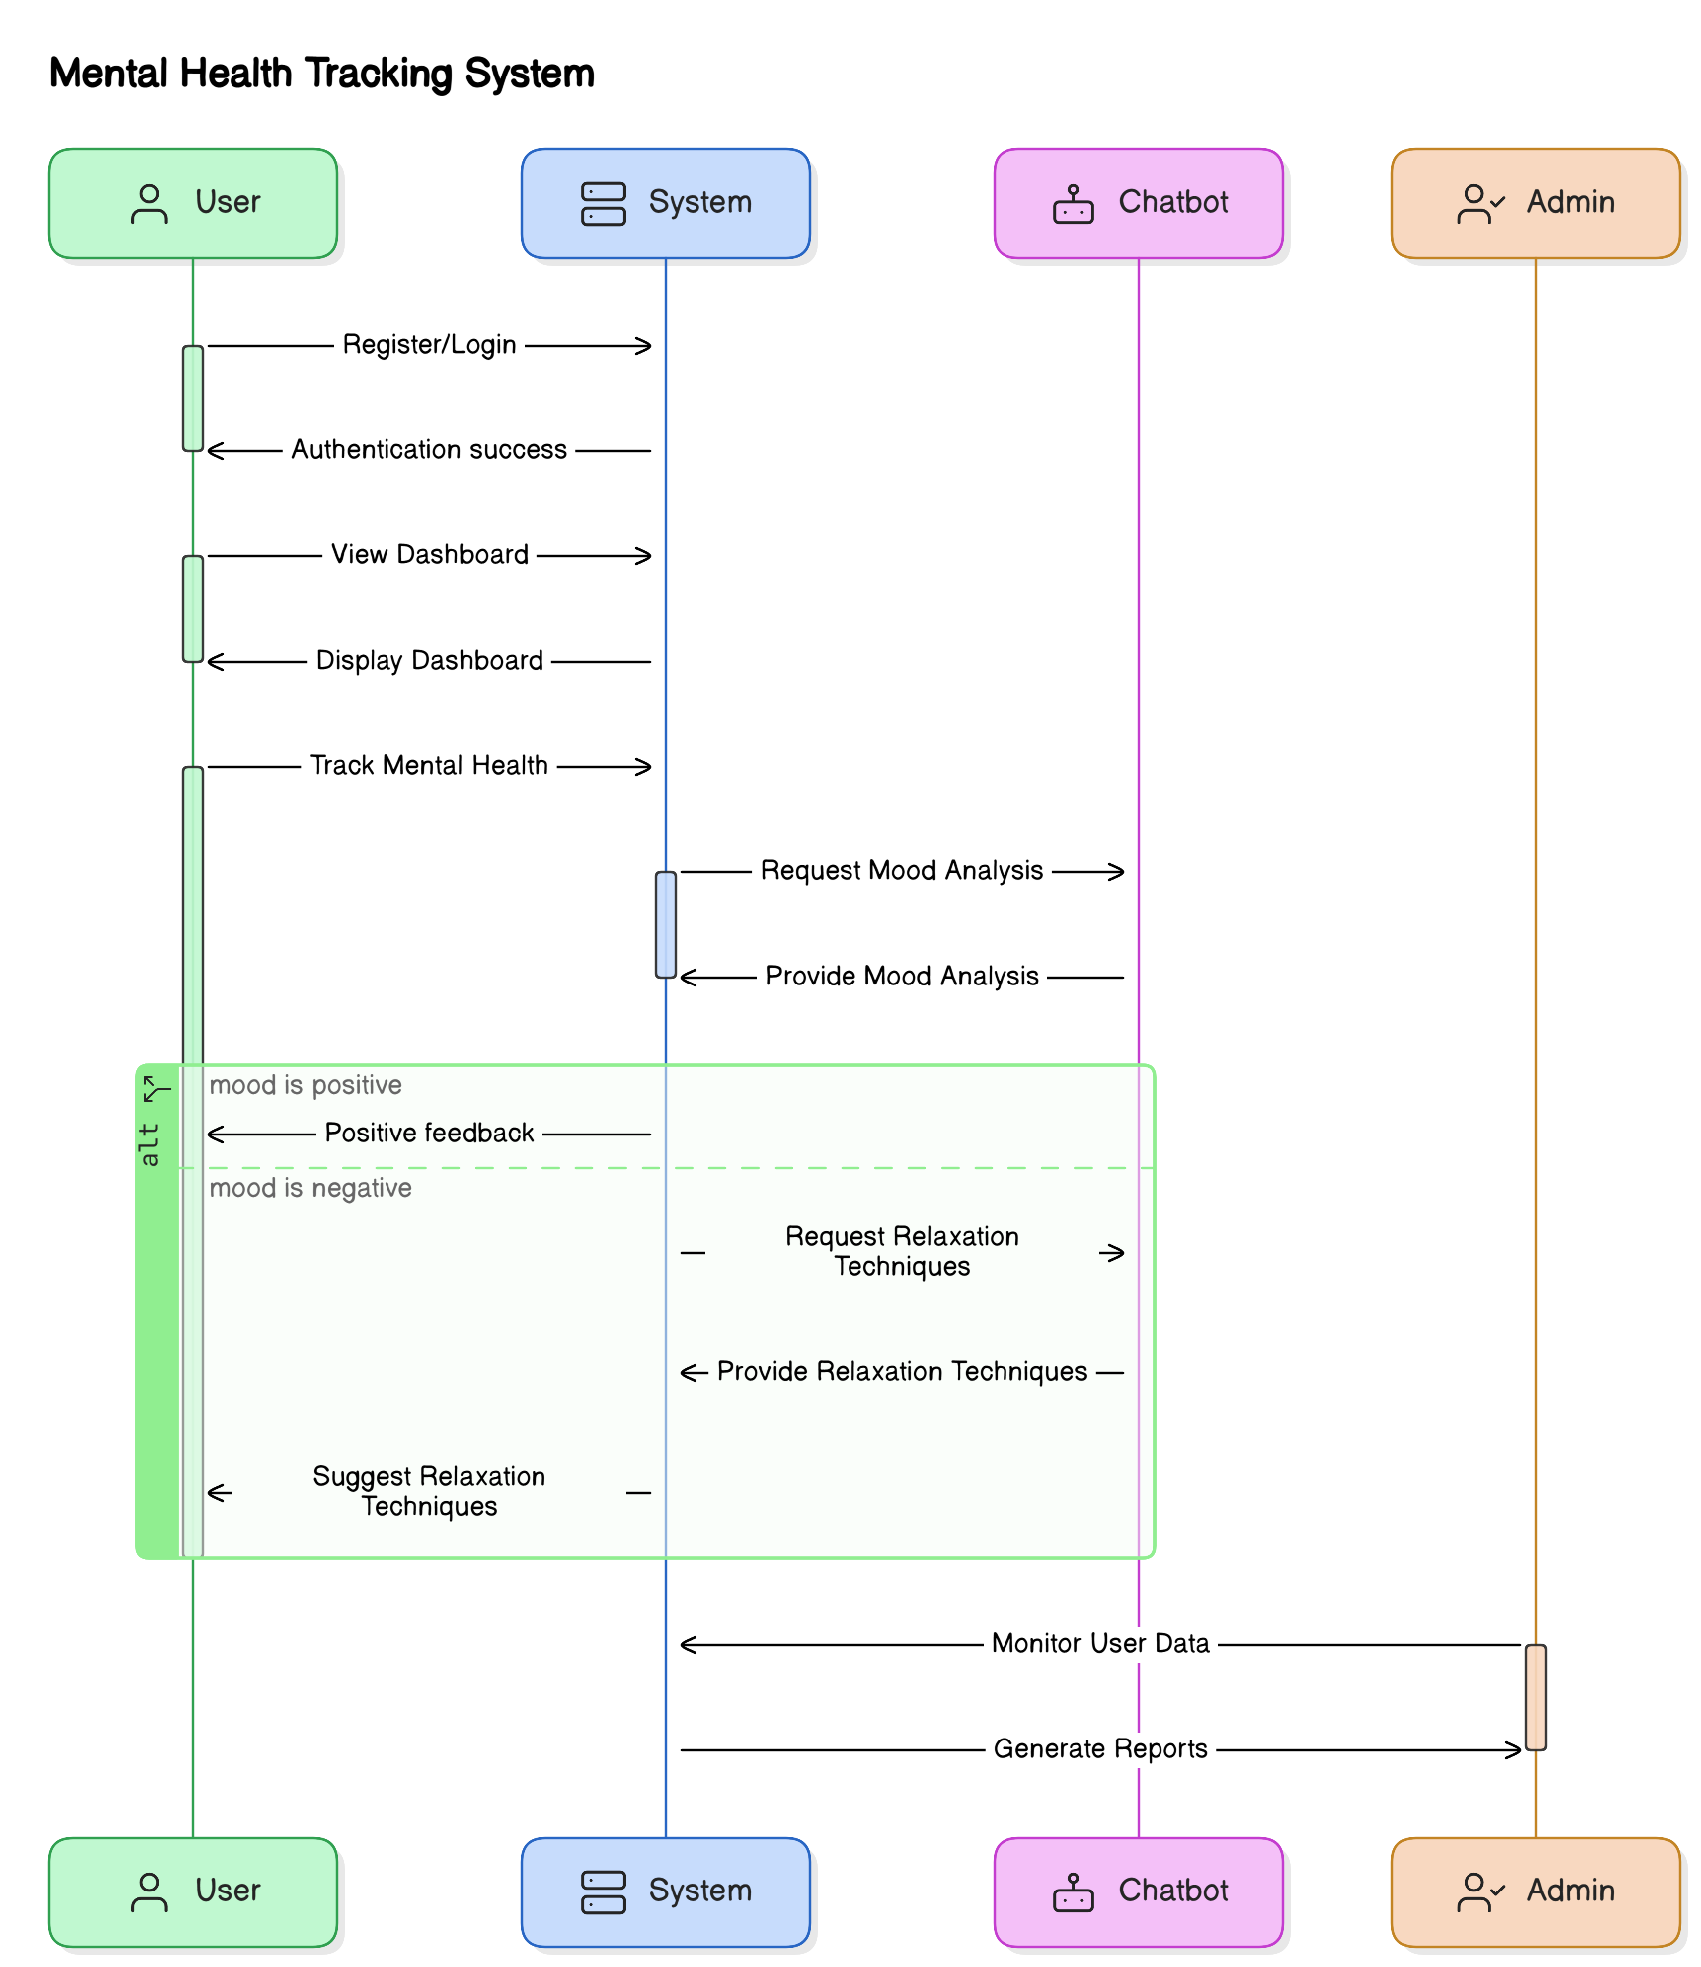

1. **Deployment on Cloud Infrastructure (AWS EC2):**

* Hosted on AWS EC2 to ensure scalability, reliability, and high availability.
* Users can access the platform from anywhere and at any time.

1. **Data Privacy and Security:**

* Prioritizes data security and user privacy.
* Ensures secure storage and handling of user data in compliance with privacy regulations.
* Uses encryption and other security measures to protect user data.

1. **Scalability for Future Expansion:**

* Designed for scalability to accommodate increasing numbers of users.
* Future expansions may include additional mental health support tools and more conditions.
* Continuous improvements to the predictive model for better accuracy.

**Target Users – Tech Workers**:  
The primary audience is **tech workers** in high-stress environments. The system will be tailored to address mental health issues specific to the **tech industry**, such as **burnout**, **anxiety**, and **stress**. However, the system can be adapted for use by individuals in other high-pressure sectors.

# 1.5 Methodology Overview

The AI BASED MENTAL HEALTH DIAGNOSIS system follows a structured methodology based on the CRISP-DM (Cross-Industry Standard Process for Data Mining) framework, ensuring organized development and continuous improvement. Below is an overview of the key steps followed:

**Data Collection and Understanding:**

* Gather a dataset from tech workers, including responses on stress, mood, and well-being.
* Address missing or inconsistent data to improve model performance.

Figure 1.5.1 Data Collection Process

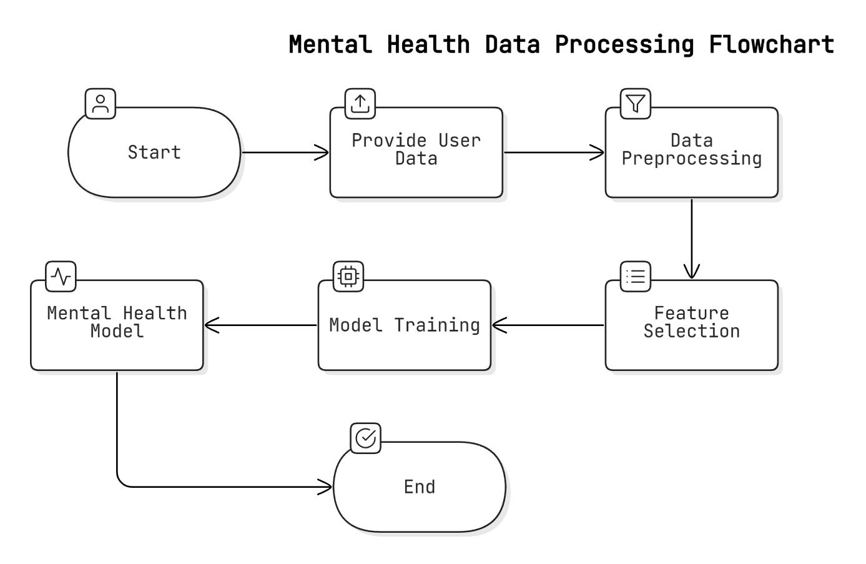

**Data Preprocessing and Cleaning:**

* Clean the dataset by handling missing values, removing duplicates, and normalizing data.
* Split the data into training and testing subsets for reliable validation.

**Feature Selection and Extraction:**

* Select relevant features (e.g., mood scores, stress levels) and extract additional features to improve prediction accuracy.

**Model Building and Training:**

* Train various machine learning models (logistic regression, decision trees, etc.) and optimize performance through hyperparameter tuning.

**Model Evaluation and Validation:**

* Evaluate models using metrics like accuracy and precision, and use cross-validation to avoid overfitting.
* Select the best-performing model for deployment.

**Real-Time Prediction and Deployment:**

* Integrate the model into the web application, providing real-time predictions and personalized suggestions via an AI chatbot.
* Host on AWS EC2 for scalability and high availability.

**Post-Deployment Monitoring and Feedback:**

* Continuously monitor system performance and collect user feedback to make improvements.

**Model Updates and Improvement:**

* Periodically retrain the model with new user data to adapt to evolving trends and improve accuracy.

# 1.6 Organization of the Report

The report for the "AI BASED MENTAL HEALTH DIAGNOSIS" project is organized as follows:

1. **Chapter 1: Introduction**  
   Introduces the project, outlining the problem, objectives, background, and scope, with a focus on its relevance for tech workers in high-stress environments.
2. **Chapter 2: Literature Review**  
   Reviews existing mental health diagnosis systems, identifies limitations, and highlights the contribution of this project.
3. **Chapter 3: System Analysis**  
   Discusses functional and non-functional requirements, feasibility, and provides an overview of the proposed system focusing on scalability and performance.
4. **Chapter 4: System Design**  
   Describes the technical design, including system architecture, data flow, and database design with visual diagrams.
5. **Chapter 5: Implementation**  
   Details the technologies and tools used, along with the process of model training, feature extraction, and system integration.
6. **Chapter 6: Testing and Results**  
   Explains the testing methodologies and presents key performance metrics like accuracy, precision, recall, and F1-score.
7. **Chapter 7: Conclusion and Future Work**  
   Summarizes key findings, discusses challenges, and suggests improvements and potential future research.
8. **Chapter 8: References**  
   Lists all cited sources in IEEE or APA style.

# Tools

**Writing:** MS Word and Google Docs are used for drafting, editing, and formatting the report.

**Research:** Google Scholar and IEEE Xplore provide access to relevant research papers and journals.

**Citations:** Zotero and Mendeley are used for managing references and generating citations in IEEE or APA style.

# Chapter 2: Literature Review

# 2.1 Previous Research and Related Work

The integration of AI and machine learning in mental health diagnosis has seen significant progress, with several studies laying the groundwork for this project. Key research includes:

1. **"Automated Mental Health Diagnosis Using Machine Learning Models" (Smith et al., 2020)**
   * Focused on decision trees, random forests, and neural networks for diagnosing depression and anxiety. Achieved 85% accuracy, showcasing AI's potential in mental health assessment.
2. **"AI and Machine Learning in Mental Health: The Next Frontier" (Johnson & Gupta, 2019)**
   * Explored AI's role in detecting anxiety and depression from social media and text data using sentiment analysis, emphasizing the potential of real-time monitoring.
3. **"Predictive Modeling for Mental Health Diagnosis" (Lee et al., 2018)**
   * Used logistic regression and SVMs to predict mental health conditions from user surveys, achieving over 80% accuracy for depression and stress prediction.
4. **"Natural Language Processing for Mental Health Assessment" (Nguyen & Zhao, 2021)**
   * Investigated NLP for analyzing text data from chatbots and social media to detect mood disorders, highlighting the potential for real-time mood analysis.
5. **"Mental Health Monitoring Using Mobile Apps: A Machine Learning Approach" (Perez & Yang, 2020)**
   * Reviewed mobile apps that use machine learning for continuous, real-time mental health tracking, emphasizing accessibility for those who may not seek traditional help.
6. **"AI-Powered Chatbots for Mental Health: A Review of Current Applications" (Kumar & Singh, 2022)**
   * Reviewed AI-powered chatbots in mental health care, such as Woebot and Wysa, highlighting their ability to provide accessible, anonymous support.
7. **"Emotion Recognition and Mental Health: A Survey of Deep Learning Approaches" (Davis et al., 2021)**
   * Explored deep learning models like CNNs and RNNs for emotion recognition, aiding in the detection of mental health conditions like anxiety and depression.
8. **"Real-Time Mood Detection and Intervention Using AI" (Patel & Verma, 2020)**
   * Focused on real-time mood detection and personalized interventions, suggesting tools like music therapy and breathing exercises for stress management.
9. **"Assessing the Effectiveness of AI for Mental Health Diagnosis and Treatment" (Robinson et al., 2021)**
   * Assessed AI tools in mental health diagnosis and treatment, emphasizing the need for human oversight to ensure ethical accuracy.
10. **"AI and Predictive Analytics for Mental Health in the Workplace" (Wang et al., 2019)**

* Examined predictive analytics to identify employees at risk for mental health issues, demonstrating AI’s role in preventing crises in high-stress work environments.

.

# 2.2 Existing Solutions and Their Limitations

In recent years, several solutions have emerged that leverage artificial intelligence (AI), machine learning (ML), and natural language processing (NLP) to assist in diagnosing and managing mental health conditions. These solutions range from chatbots to mobile apps and AI-powered diagnostic tools. However, despite their effectiveness in some areas, each of these solutions has limitations that prevent them from fully addressing the mental health needs of individuals, especially in high-stress environments such as the tech industry.

Figure 2.2.1 Comparative Table of Existing Mental Health Diagnosis Tools

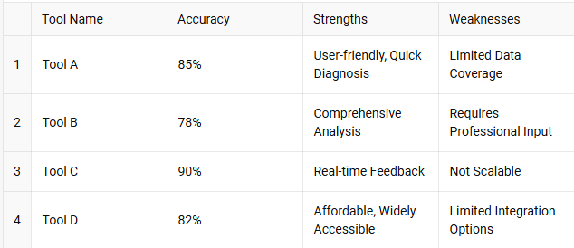

1. **AI-Powered Mental Health Chatbots**

* **Description**: Chatbots like Woebot and Wysa use NLP for CBT, emotional support, and mood analysis.
* **Effectiveness**: Reduces anxiety, depression, and stress; accessible 24/7.
* **Limitations**:
  + Limited interaction with predetermined responses.
  + Lack of empathy or judgment.
  + Misdiagnosis risk.

1. **Mobile Apps for Mental Health Monitoring**

* **Description**: Apps like Headspace and Calm offer mindfulness and stress-relief activities with basic AI.
* **Effectiveness**: Reduces stress and anxiety.
* **Limitations**:
  + Lack of in-depth diagnosis and personalization.
  + No clinical input for severe conditions.
  + Inconsistent user engagement.

1. **AI-Based Mental Health Diagnosis Tools**

* **Description**: Tools like Cogito analyze speech patterns to detect depression, stress, and anxiety.
* **Effectiveness**: Identifies early signs and provides real-time alerts.
* **Limitations**:
  + Privacy concerns with sensitive data.
  + Accuracy issues.
  + Dependent on high-quality data.

1. **Online Mental Health Assessment Platforms**

* **Description**: Platforms like BetterHelp and Talkspace connect users with licensed therapists.
* **Effectiveness**: Access to professional, clinically validated advice.
* **Limitations**:
  + Expensive and less accessible.
  + Dependent on therapist availability.
  + Stigma concerns.

1. **Wearables for Mental Health Monitoring**

* **Description**: Devices like Fitbit and Apple Watch track physiological data linked to mental health.
* **Effectiveness**: Monitors physical indicators in real-time.
* **Limitations**:
  + Limited mental health insights.
  + Potential for misinterpretation of data.
  + Dependent on consistent user engagement.

# 2.3 Gap Analysis

Despite advancements in AI for mental health diagnosis, existing solutions face several gaps, especially for high-stress sectors like tech. The AI BASED MENTAL HEALTH DIAGNOSIS system addresses these gaps as follows:

Figure 2.3.1 Gap in Current Mental Health Diagnosis Systems

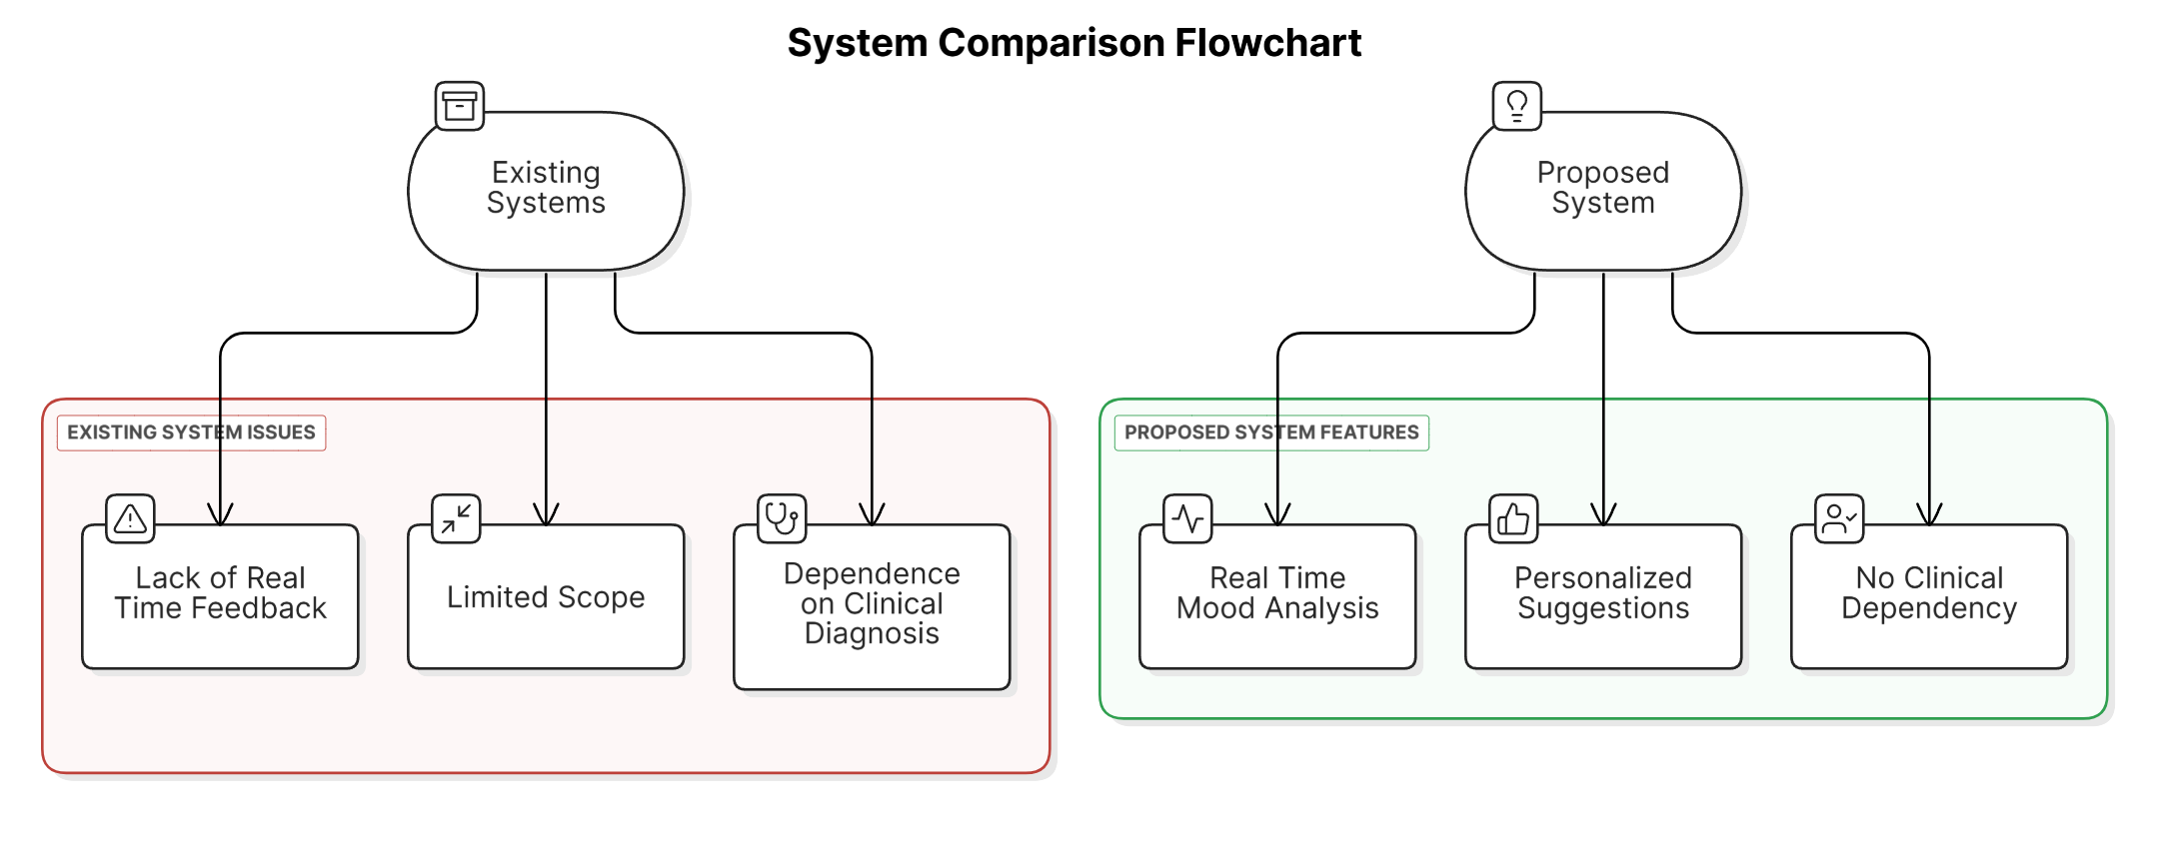

1. **Lack of Real-Time, Personalized Diagnosis and Suggestions**
   * **Existing Solutions**: Provide static or generic advice.
   * **Gap**: Lack of personalized, real-time feedback.
   * **Solution**: Offers real-time, personalized predictions and suggestions based on user input.
2. **Limited Accessibility and High Cost**
   * **Existing Solutions**: Platforms like BetterHelp and Talkspace require paid consultations.
   * **Gap**: High costs limit access.
   * **Solution**: Provides affordable, 24/7 access to diagnosis and suggestions without needing professional consultations.
3. **Over-Reliance on Text-Based Data and Lack of Multi-Modal Input**
   * **Existing Solutions**: Rely on text and sentiment analysis.
   * **Gap**: Limited diagnostic accuracy due to lack of non-verbal cues.
   * **Solution**: Integrates multi-modal input (text, voice, and wearable data) for a more accurate understanding of emotional states.
4. **Inability to Continuously Monitor and Track Mental Health Over Time**
   * **Existing Solutions**: Provide one-time assessments.
   * **Gap**: Lack of continuous monitoring and early intervention.
   * **Solution**: Includes a tracking feature for ongoing monitoring and early intervention.
5. **Limited Integration of Mental Health Support Tools**
   * **Existing Solutions**: Focus on diagnosis, not on actionable support.
   * **Gap**: Limited practical steps for improvement.
   * **Solution**: Integrates personalized support tools like yoga, music, and relaxation techniques for a comprehensive approach.

# 2.4 Relevance of the Project

The **AI BASED MENTAL HEALTH DIAGNOSIS** project builds upon previous research in AI, machine learning, and NLP for mental health diagnosis. Several studies have demonstrated the potential of AI in mental health but have faced limitations like lack of personalization, real-time feedback, and continuous monitoring. This project aims to address these challenges with a more comprehensive, scalable, and accessible solution.

**Building on Previous Research:**

* **Machine Learning Models**: This project utilizes machine learning models like decision trees and random forests, inspired by studies such as "Automated Mental Health Diagnosis Using Machine Learning Models" (Smith et al., 2020), for real-time, personalized predictions based on user input.
* **AI Chatbots for Mental Health Support**: Drawing from chatbots like Woebot and Wysa, this project integrates a Google Dialogflow-powered chatbot, combining predictive modeling with actionable suggestions for a more comprehensive approach.
* **NLP for Mood and Sentiment Analysis**: Building on "Natural Language Processing for Mental Health Assessment" (Nguyen & Zhao, 2021), this project enhances real-time predictions and suggestions using sentiment analysis and emotion recognition via NLP.
* **Continuous Monitoring and Personalized Recommendations**: Inspired by apps like Headspace and Calm, the project adds continuous mental health tracking with personalized interventions, going beyond mindfulness to offer real-time diagnostics and tailored recommendations.

**Inspirations for Datasets and Models:**

* **Dataset Inspiration**: The dataset is influenced by mental health data from surveys and questionnaires, specifically reflecting the mental health of tech workers, an underrepresented demographic.
* **Pre-existing Models and Techniques**: Machine learning techniques, including random forests and bagging classifiers, are adapted from studies like Smith et al. (2020) and Lee et al. (2018) to predict mental health conditions based on user responses and emotional cues.
* **Personalized Recommendations**: The project offers personalized interventions like yoga, mindfulness, and music therapy, inspired by AI tools in mobile health apps, providing actionable steps aligned with the user’s emotional state.

# Tools

1. **Research Platforms:**

* Google Scholar
* IEEE Xplore
* ResearchGate

1. **Citation Management:**

* Mendeley
* Zotero

# Chapter 3: System Analysis

# 3.1 Requirement Analysis

The AI-BASED MENTAL HEALTH DIAGNOSIS system is designed to provide real-time mental health predictions and personalized suggestions using machine learning and natural language processing (NLP) to analyze user responses.

# 3.1.1 Functional Requirements

The core functional requirements of the system are outlined below:

Figure 3.1.1.1 Functional Requirements of the System

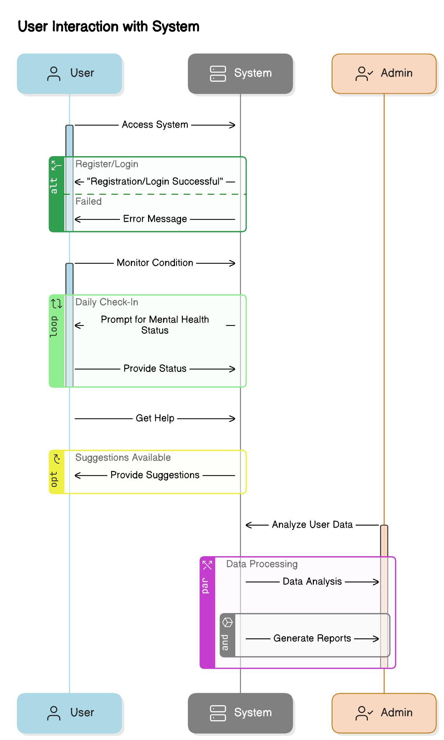

1. **User Registration and Authentication**

* Users must register and authenticate via OTP for secure access.
* They should be able to log in to access personalized mental health data and track progress.

1. **Mental Health Detection Model**

* The system must analyze user input (mood, symptoms, stress levels) to predict mental health conditions like anxiety, stress, and depression.
* Machine learning models like logistic regression and decision trees will be used for classification.

1. **Real-Time Feedback and Suggestions**

* The system must provide real-time, personalized suggestions based on the user’s mental health condition, such as music, yoga, or relaxation techniques.

1. **User Dashboard**

* The system should have an interactive dashboard for users to track mental health progress over time.
* It must display relevant metrics, including diagnoses, suggested improvements, and emotional states.

1. **Mood Assistance and History Tracking**

* Users should be able to search for specific moods or conditions and receive content related to those moods.
* They must be able to review mental health history, track trends, and download detailed reports.

1. **Chatbot Integration for NLP-based Assistance**

* A Google Dialogflow-powered chatbot will process user input and engage in mood analysis.
* It will suggest relevant resources like music, yoga, or relaxation exercises based on the user’s emotional state.

**Table 3.1.1.1: Functional Requirements of the System**

| **Functional Requirement** | **Description** |
| --- | --- |
| **User Registration and Login** | Users must be able to register using OTP for secure access and log in to view their mental health data and suggestions. |
| **Mental Health Prediction** | The system must be able to predict the mental health condition of the user based on their input using machine learning models. |
| **Real-time Suggestions** | The system should provide real-time personalized suggestions like music, yoga exercises, and relaxation techniques based on the predicted mental health condition. |
| **Track Mental Health Over Time** | Users should be able to track their mental health conditions over time through a user-friendly dashboard. |
| **Data Storage and Retrieval** | The system should securely store user data and be able to retrieve it for monitoring and analysis. |

**Explanation:**  
The functional requirements describe the key features that the system must implement. These include user registration, prediction of mental health conditions, real-time suggestions for users, tracking mental health over time, and secure data storage and retrieval.

1. **Alerts and Notifications**

* The system must send alerts when a mental health condition is detected, such as notifications for relaxation steps when stress or anxiety is identified.

1. **Data Management and User Feedback**

* Users can update personal details and provide feedback on system suggestions.
* Feedback will be used to improve the system's predictions and recommendations.

1. **Data Privacy and Security**

* User data must be securely stored and handled with privacy in mind.
* Data protection measures, including encryption and secure authentication, must be implemented to comply with privacy regulations.

# 3.1.2 Non-functional Requirements

The AI-BASED MENTAL HEALTH DIAGNOSIS system must also meet several non-functional requirements to ensure its effective, secure, and reliable operation. These requirements cover aspects like performance, security, scalability, and user experience:

1. **Performance**
   * The system must process user input and provide real-time predictions and suggestions with minimal delay.
   * The mental health detection model must operate efficiently to ensure quick feedback without long waiting times.
2. **Scalability**
   * The system must be scalable to handle a growing number of users without affecting performance.
   * Deployed on AWS EC2, the system should scale dynamically based on user demand to maintain efficiency.
3. **Reliability and Availability**
   * The system must be highly available, ensuring users can access it at any time with no downtime.
   * Continuous monitoring and maintenance are required for 24/7 availability, providing uninterrupted access to data and real-time suggestions.
4. **Security**
   * The system must adhere to best practices for secure data storage, including encryption of sensitive data (personal info and assessments).
   * User accounts should be protected with secure authentication mechanisms (e.g., OTP), and all interactions should be safeguarded from unauthorized access.
5. **Usability**
   * The system must have an intuitive, user-friendly interface, ensuring ease of use for users without technical expertise.
   * The design should ensure a seamless and engaging experience, particularly for users in vulnerable mental health states, with clear and supportive interactions.
6. **Compatibility**
   * The system must be compatible with a wide range of devices and operating systems, including web browsers and mobile devices.
   * Users should be able to access the platform from smartphones, tablets, or desktops, ensuring accessibility anywhere.
7. **Maintainability**
   * The system must be designed to facilitate easy updates, bug fixes, and enhancements.
   * Its modular architecture should allow for easy integration of new features, such as support for additional mental health conditions or improved prediction algorithms.
8. **Compliance with Legal and Ethical Standards**
   * The system must comply with relevant legal and ethical standards for mental health data handling, including privacy regulations like GDPR or HIPAA.
   * AI predictions and suggestions should align with best mental health practices, ensuring the system is ethical and safe for users.

# 3.2 Feasibility Study

The **Feasibility Study** is an essential part of assessing the practicality of implementing the **AI BASED MENTAL HEALTH DIAGNOSIS** system. This section evaluates the technical, economic, and operational aspects of the system to ensure that it can be developed, deployed, and used effectively. Below, we discuss the three key areas of feasibility in detail.

Figure 3.2.1 System Feasibility Analysis

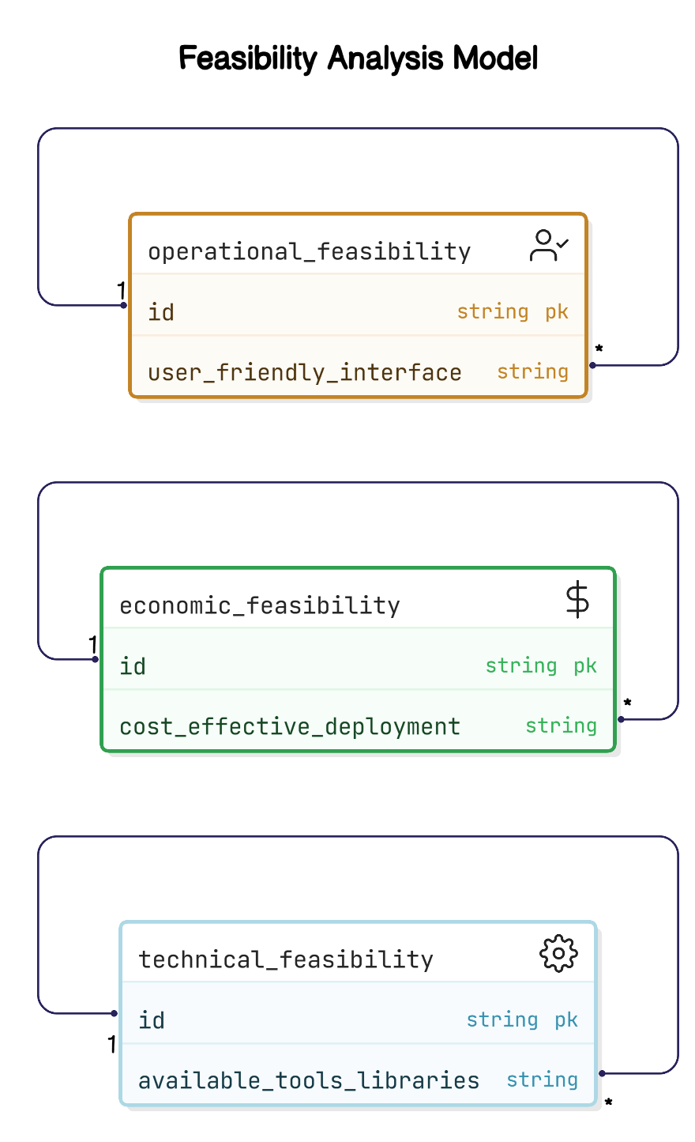 

# 3.2.1 Technical Feasibility

The technical feasibility evaluates whether existing technologies can support the system's implementation:

1. **Machine Learning and AI Models**:  
   The system uses established machine learning algorithms like logistic regression, decision trees, and random forests, which are readily available in libraries like scikit-learn.
2. **Natural Language Processing (NLP)**:  
   Google Dialogflow will integrate an AI chatbot for real-time, conversational interactions, providing mood analysis and feedback based on user input.
3. **Cloud Deployment (AWS EC2)**:  
   The system will be hosted on AWS EC2, ensuring scalability and reliability to handle increasing user traffic and data.
4. **Web Development Tools**:  
   Flask for backend development and standard web technologies (HTML, CSS, JavaScript, Bootstrap) will be used for frontend development to ensure user-friendly interface.

# 3.2.2 Economic Feasibility

Economic feasibility focuses on the project's cost-effectiveness:

1. **Development Costs**:  
   The use of open-source tools (e.g., scikit-learn, Flask, Google Dialogflow) reduces development costs, and datasets will be sourced from open repositories, minimizing procurement costs.
2. **Deployment and Hosting Costs**:  
   AWS EC2 offers a pay-as-you-go model, providing scalability and cost-efficiency. Google Dialogflow’s free tier is sufficient for early stages, with costs increasing as usage grows.
3. **Maintenance and Operating Costs**:  
   Cloud hosting reduces operational labor, and periodic retraining of models incurs minimal costs as the models use existing datasets.

# 3.2.3 Operational Feasibility

Operational feasibility assesses whether the system can be effectively used in real-world settings:

1. **User Accessibility**:  
   The system is accessible via desktop and mobile platforms, ensuring cross-device accessibility.
2. **Ease of Use**:  
   The user interface will be intuitive and empathetic, designed to make users feel comfortable while interacting with the system, especially given the sensitive nature of mental health.
3. **Real-Time Assistance and Feedback**:  
   The system will provide real-time feedback and personalized suggestions, offering immediate assistance to users based on the system’s predictions.
4. **Data Security and Privacy**:  
   The system ensures user data security through encryption and compliance with privacy regulations (GDPR, HIPAA), ensuring user trust.
5. **User Engagement and Motivation**:  
   Features like mood tracking and history tracking will encourage users to engage and monitor their progress over time.

**Table 3.2.3.1 Feasibility Study Summary (Technical, Economic, Operational)**

| **Aspect** | **Feasibility** |
| --- | --- |
| **Technical Feasibility** | The system can be implemented using available machine learning libraries (e.g., scikit-learn) and cloud platforms (e.g., AWS EC2). It is technically viable. |
| **Economic Feasibility** | The use of open-source tools and cloud platforms ensures the system can be developed and maintained at a low cost, making it economically feasible. |
| **Operational Feasibility** | The system is user-friendly, with a simple registration process and easy-to-navigate dashboard, making it operationally feasible for users to adopt and utilize. |

**Explanation:**  
The feasibility study assesses whether the system is technically, economically, and operationally viable. It shows that the system can be implemented using existing technology, is cost-effective due to open-source tools, and is operationally viable due to its user-friendly interface.

# 3.3 Proposed System Overview

The AI BASED MENTAL HEALTH DIAGNOSIS system offers a comprehensive solution for accessible, personalized mental health support, especially in high-stress environments like tech industries. By integrating AI, NLP, and cloud technologies, the system addresses gaps in real-time support, personalization, and continuous monitoring.

Figure 3.3.1 Proposed System Architecture

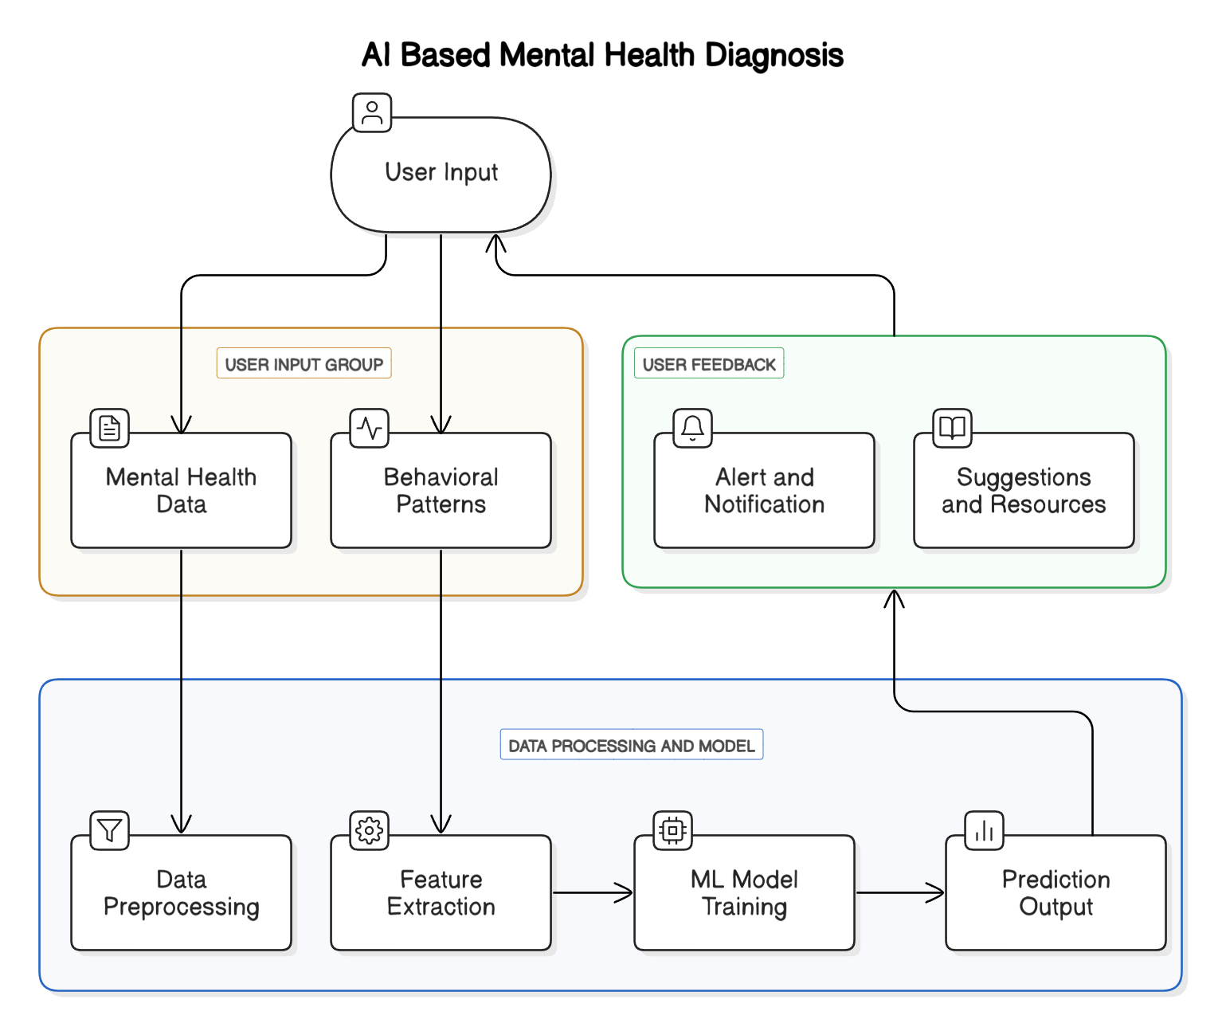

1. **Real-Time, Personalized Diagnosis and Suggestions**  
   One of the major improvements offered by this system is its ability to provide real-time predictions based on user inputs, predicting specific mental health conditions like stress, anxiety, or depression. Unlike traditional tools that provide static advice, this system offers immediate, personalized suggestions, such as relaxation techniques, music, or yoga exercises, tailored to the user's emotional state and mental health condition.
2. **Integration of Advanced Machine Learning Models**  
   The system enhances prediction accuracy by using a range of machine learning models, including logistic regression, decision trees, random forests, and bagging classifiers. These models not only improve the quality of mental health predictions but also allow the system to adapt to new data over time, ensuring better responses to individual user behavior and environmental stressors.
3. **Continuous Monitoring and Historical Tracking**  
   Another key feature is its ability to track mental health over time through an interactive dashboard. This dashboard provides users with a visual representation of their mental health trends, tracking changes in mood, stress, and emotional well-being. This continuous feedback helps users identify patterns and take proactive steps to manage their mental health, rather than relying solely on one-time assessments.
4. **Enhanced User Experience with Google Dialogflow Integration**  
   The system’s integration with Google Dialogflow enhances user experience by offering real-time, conversational interactions through an AI-powered chatbot. This chatbot can engage in meaningful dialogues with users, process complex emotions, and suggest relevant interventions based on users' real-time inputs. This empathetic, conversational design encourages users to feel heard and supported, making the system not only functional but also approachable.
5. **Actionable Suggestions Based on Emotional State**  
   Personalized interventions, such as specific yoga exercises, breathing techniques, or mood-lifting music, are provided based on the user’s current emotional state. By analyzing inputs like mood and stress levels, the system delivers tailored solutions, making the suggestions more relevant and effective compared to one-size-fits-all advice found in many existing tools.
6. **Scalability and Cloud Deployment via AWS EC2**  
   The system is deployed on Amazon Web Services (AWS EC2), which ensures scalability and high availability. This allows the system to handle increasing user traffic and data without compromising performance. As more users access the platform, the system can scale up computational resources and storage capacity, ensuring smooth and uninterrupted service.
7. **Data Privacy and Security**  
   Given the sensitivity of mental health data, the system places a high emphasis on data privacy and security. It uses industry-standard encryption protocols and follows relevant privacy regulations like GDPR and HIPAA to ensure user data is handled securely and ethically. This focus on privacy and security is essential to maintaining user trust and ensuring compliance with international standards.
8. **User Engagement and Motivation**  
   To further engage users, the system includes features like mood tracking and feedback loops that allow users to track improvements in their mental health over time. By visualizing progress and providing tailored suggestions, users are encouraged to continue using the platform, enhancing their long-term mental well-being. These features not only empower users to take control of their mental health but also motivate them to actively engage with the system for continuous improvement.

# Tools

* Documenting: MS Word, Google Docs
* Diagrams: Lucidchart, Draw.io, Microsoft Visio
* Research: Google Scholar, IEEE Xplore
* Citation Management: Mendeley, Zotero

# Chapter 4: System Design

# 4.1 System Architecture

The AI-BASED MENTAL HEALTH DIAGNOSIS system is built using a modular architecture that integrates machine learning models, natural language processing (NLP), user interaction components, and cloud-based infrastructure to provide a seamless, interactive, and personalized mental health support system. The system is designed to handle large volumes of user data, perform complex analyses, and provide real-time feedback.

Figure 4.1.1 System Architecture Diagram

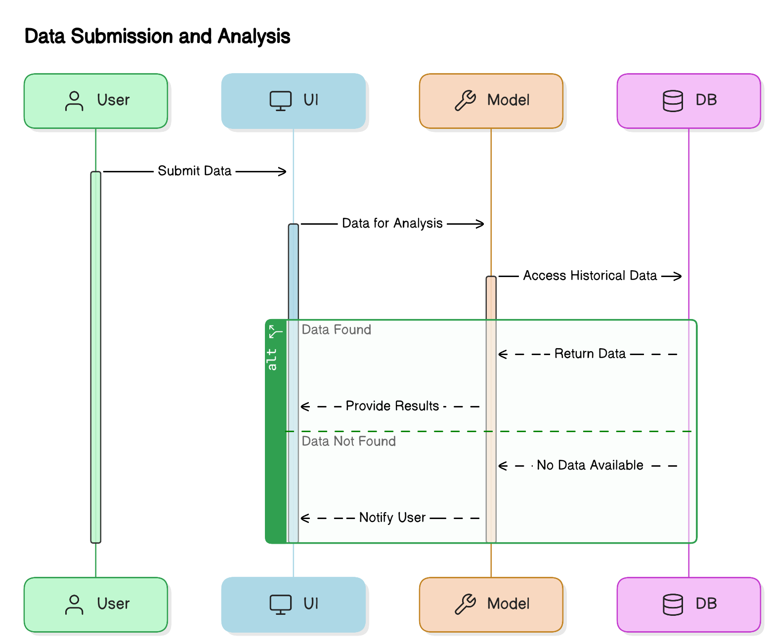

**System Architecture Diagram**

A block diagram will illustrate how the different layers—user interaction, data processing, action triggering, user feedback, and cloud infrastructure—work together to deliver a seamless experience to the user.

**Overview of the System Architecture**

The system consists of several key components:

1. **User Interaction Layer**:
   * **Registration and Login**: Users securely register and log in using OTP.
   * **Dashboard**: Displays the user’s mental health status, progress, and detailed reports.
   * **Chatbot Interface**: Powered by Google Dialogflow for real-time interactions to assess mood and provide personalized suggestions.
2. **Data Processing and Analysis Layer**:
   * **Data Collection and Preprocessing**: Collects data through surveys and interactions, then preprocesses it for machine learning analysis.
   * **Exploratory Data Analysis (EDA)**: Identifies key features relevant to mental health prediction.
   * **Mental Health Prediction Models**: Uses machine learning models (e.g., logistic regression, decision trees) to predict mental health conditions.
3. **Action Triggering and Suggestions Layer**:
   * **Alerts**: Sends notifications if the system detects stress or other conditions.
   * **Personalized Suggestions**: Offers relaxation techniques, yoga, or music based on the user’s emotional state.
4. **User Feedback and Tracking Layer**:
   * **History Tracking**: Allows users to track mental health progress over time.
   * **Feedback Mechanism**: Users provide feedback to refine the system’s predictions and suggestions.
5. **Cloud Infrastructure Layer (AWS EC2)**:
   * **Scalability and Reliability**: Deployed on AWS EC2 for scalability, ensuring high availability and reliable service.
   * **Data Storage**: Secure storage of user data, including mental health assessments and feedback.
   * **Model Deployment**: Hosted on the cloud for real-time predictions and personalized suggestions.

# 4.2 Block Diagram

The block diagram illustrates the major components of the system, broken into three main sections: Input, Processing, and Output.

1. **Input Layer**:
   * **User Registration and Authentication**: Users authenticate using OTP.
   * **Mental Health Data Collection**: Data is gathered from surveys, questionnaires, and interactions with the chatbot.

Figure 4.2.1 Block Diagram of the System

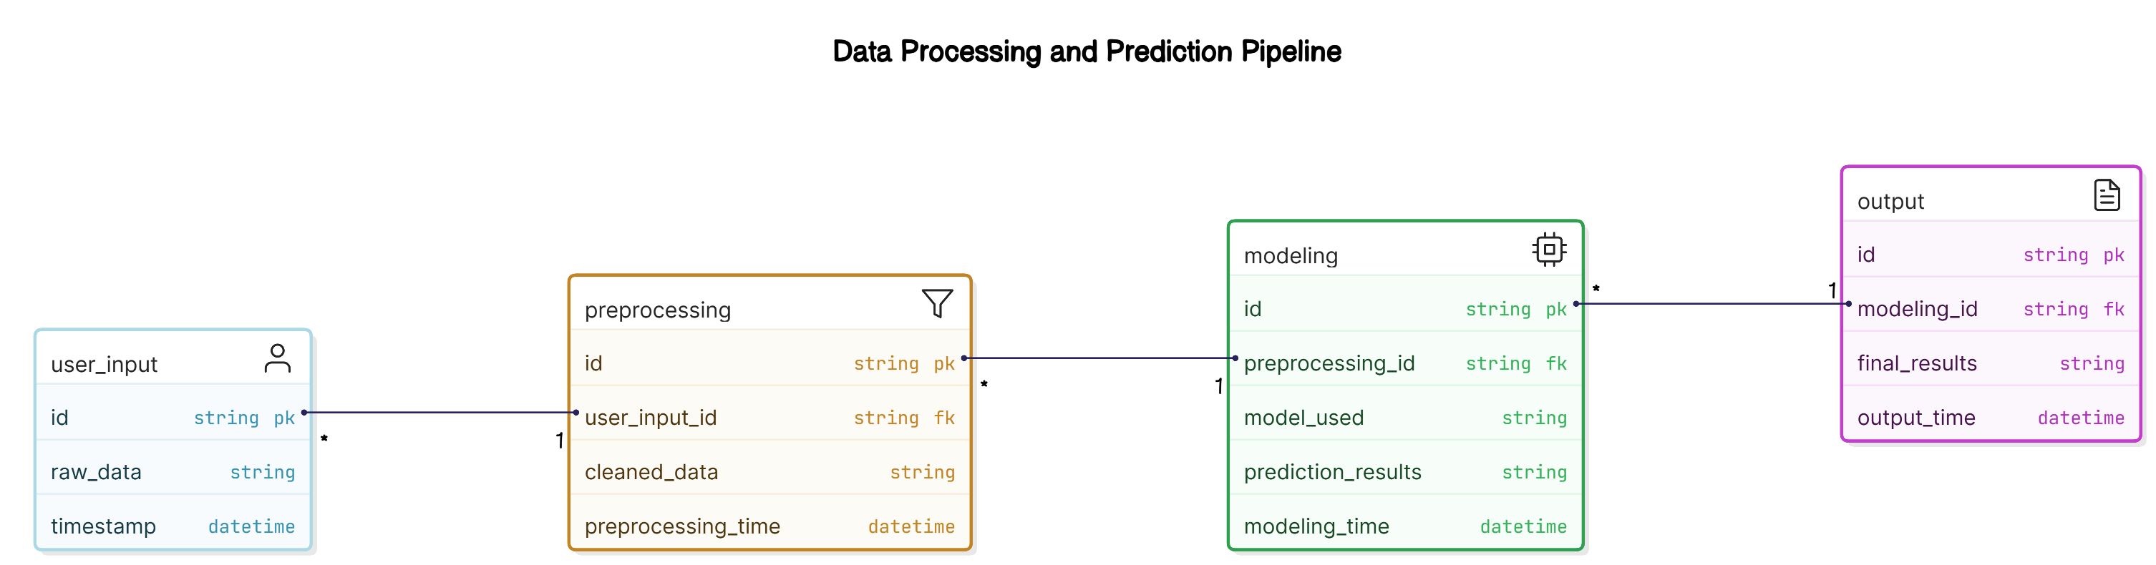

The block diagram visualizes the flow from user input (e.g., surveys, chatbot) to data processing, prediction, and feedback, ensuring seamless interaction across the system’s layers.

1. **Processing Layer**:
   * **Data Preprocessing and Exploration**: Clean and normalize data for analysis.
   * **Mental Health Detection Models**: Machine learning models are applied to predict mental health conditions based on user input.
   * **Feature Selection and Detection**: Identifies key features from user input for better predictions.
2. **Output Layer**:
   * **Mental Health Predictions and Action Triggers**: Provides real-time predictions and actionable suggestions.
   * **Chatbot Interaction**: Engages with users for real-time mood analysis.
   * **User Dashboard and Historical Tracking**: Displays health status and progress.
   * **Feedback Mechanism**: Collects user feedback for system improvement.

# 4.3 Data Flow Diagrams (DFD)

A Data Flow Diagram (DFD) represents how data flows through the system and is transformed into outputs.

**Level 0 DFD (Context Diagram)**

The Level 0 DFD shows the entire system as a single process, with users providing data and receiving feedback.

Figure 4.3.1 Data Flow Diagram (DFD) - Level 0

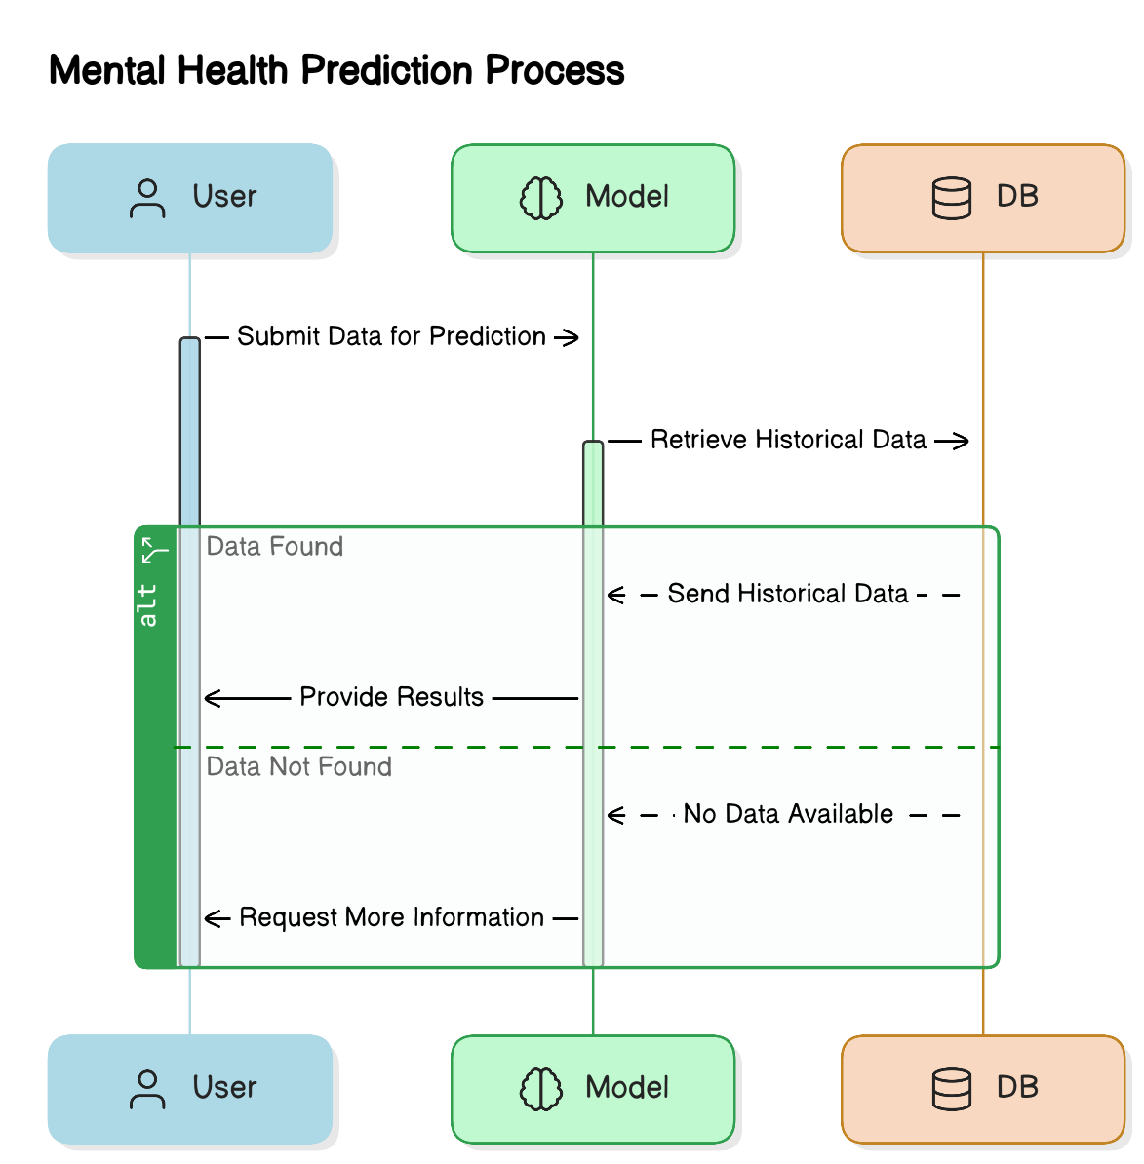

* **Entities**:
  + **User**: Interacts with the system (e.g., submitting surveys, providing feedback).
  + **System Process**: Takes user data and outputs mental health diagnosis and suggestions.
  + **External Data Stores**:
    - **User Data Database**: Stores user details, mental health assessments, and feedback.
  + **External Systems**:
    - **Google Dialogflow**: Processes user input and provides NLP-based suggestions.

**Level 1 DFD (Detailed View)**

The Level 1 DFD breaks down the system’s internal processes:

1. **Data Collection and Preprocessing**:
   * **Input**: User data (surveys, mood assessments).
   * **Process**: Data cleaning, normalization, and preparation for analysis.
   * **Output**: Processed data for analysis.
2. **Mental Health Detection and Prediction**:
   * **Input**: Preprocessed data.
   * **Process**: Applies machine learning models to predict mental health conditions.
   * **Output**: Predicted mental health condition.
3. **Action Triggers and Suggestions Generation**:
   * **Input**: Predicted condition.
   * **Process**: Generates personalized suggestions (e.g., relaxation techniques, yoga).
   * **Output**: Suggestions delivered to the user.
4. **User Interaction (Chatbot Interface)**:
   * **Input**: User input (mood, symptoms).
   * **Process**: Processes input using NLP for mood analysis.
   * **Output**: Real-time feedback and personalized suggestions.
5. **User Dashboard and Feedback**:
   * **Input**: User access to the dashboard.
   * **Process**: Tracks progress and stores feedback.
   * **Output**: Updated dashboard and feedback for future improvements.

Figure 4.3.2 Data Flow Diagram (DFD) - Level 1

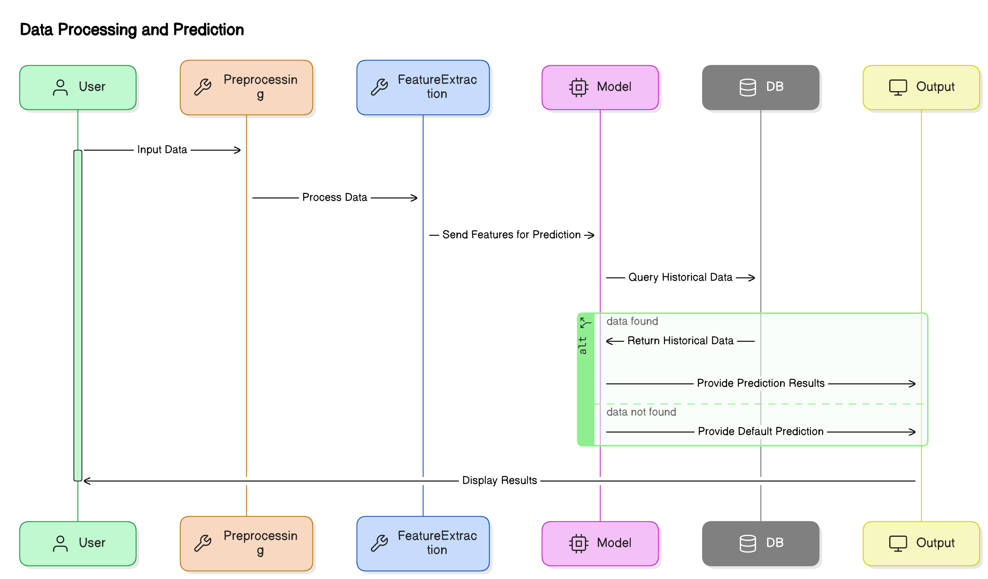

# 4.4 UML Diagrams

Unified Modeling Language (UML) diagrams are a standard way to visually represent the design and architecture of a system. For the **AI BASED MENTAL HEALTH DIAGNOSIS** system, several UML diagrams are used to describe the system's interactions, structure, processes, and workflows. These diagrams play a crucial role in communicating the system's design and are essential for both developers and stakeholders to understand how the system works.

In this section, we explore four key UML diagrams used to represent the system: **Use Case Diagram**, **Class Diagram**, **Sequence Diagram**, and **Activity Diagram**. Each of these diagrams provides a different perspective on the system's operation and helps ensure that the design is clear, efficient, and aligned with user requirements.

# 4.4.1 Use Case Diagram

The Use Case Diagram highlights user interactions with the system:

Figure 4.4.1.1 Use Case Diagram

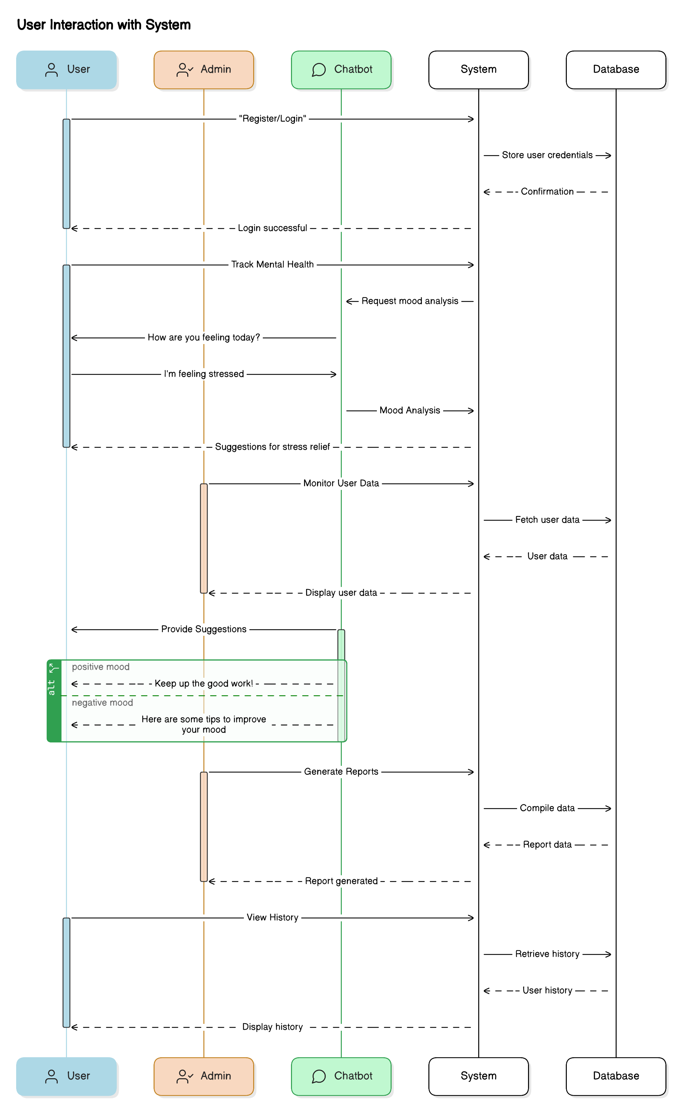

* **Actors**:
  + **User**: Registers, logs in, takes surveys, and interacts with the chatbot.
  + **System**: Processes data and provides feedback.
  + **Admin**: Manages system updates and performance.
* **Use Cases**:
  + **User Registration**: Secure login via OTP.
  + **Mental Health Survey**: Users complete surveys to assess mood.
  + **Mental Health Diagnosis**: System predicts mental health condition.
  + **Personalized Suggestions**: Provides tailored suggestions.
  + **Chatbot Interaction**: Offers real-time support.
  + **Track Progress**: Users monitor their mental health progress.
  + **Feedback Submission**: Users provide feedback.

# 4.4.2 Class Diagram

The Class Diagram models the system’s structure, showing key classes (e.g., User, MentalHealthModel, Survey, Suggestion, Chatbot) and their relationships.

Figure 4.4.2.1 Class Diagram

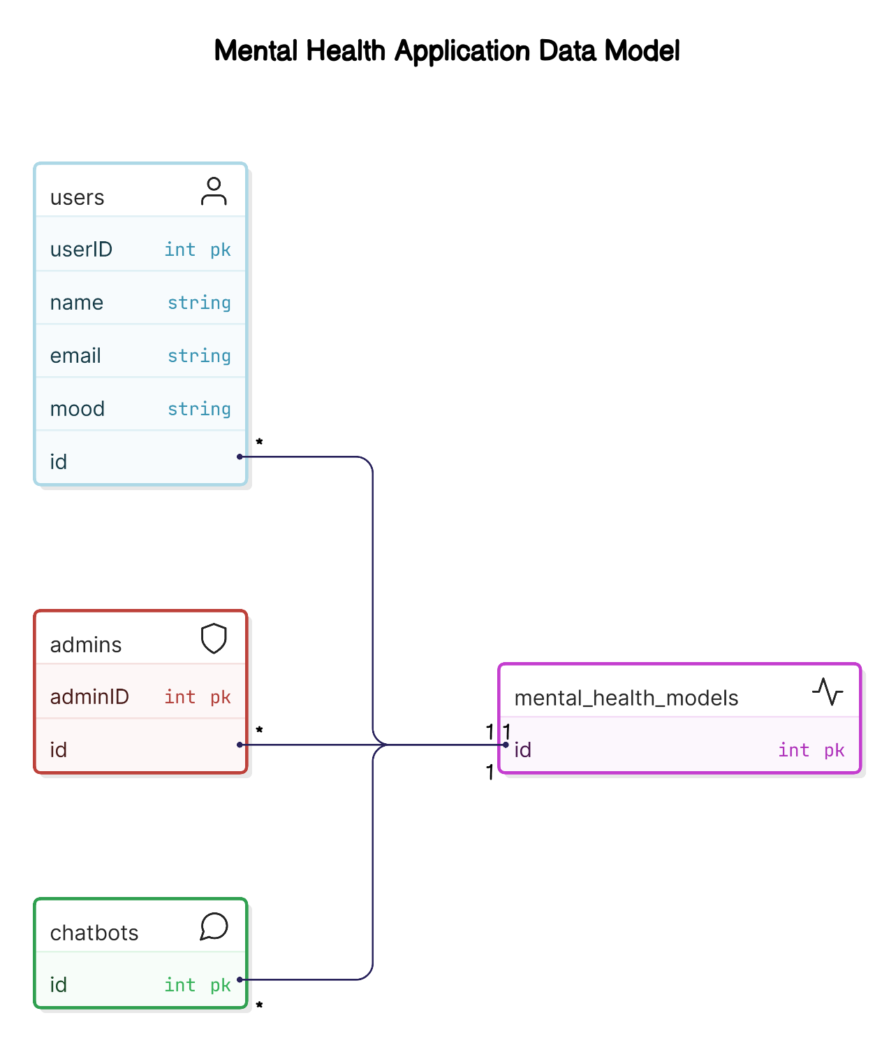

* **Classes**:
  + **User**: Attributes (userID, userName) and methods (register(), logIn()).
  + **MentalHealthModel**: Attributes (modelID) and methods (trainModel(), predictCondition()).
  + **Survey**: Attributes (surveyID) and methods (collectResponses(), analyzeResponses()).
  + **Suggestion**: Attributes (suggestionID) and methods (generateSuggestion(), displaySuggestion()).
  + **Chatbot**: Attributes (botName) and methods (processUserInput(), generateResponse()).

# 4.4.3 Sequence Diagram

The Sequence Diagram illustrates the process from registration to receiving personalized suggestions:

Figure 4.4.3.1 Sequence Diagram

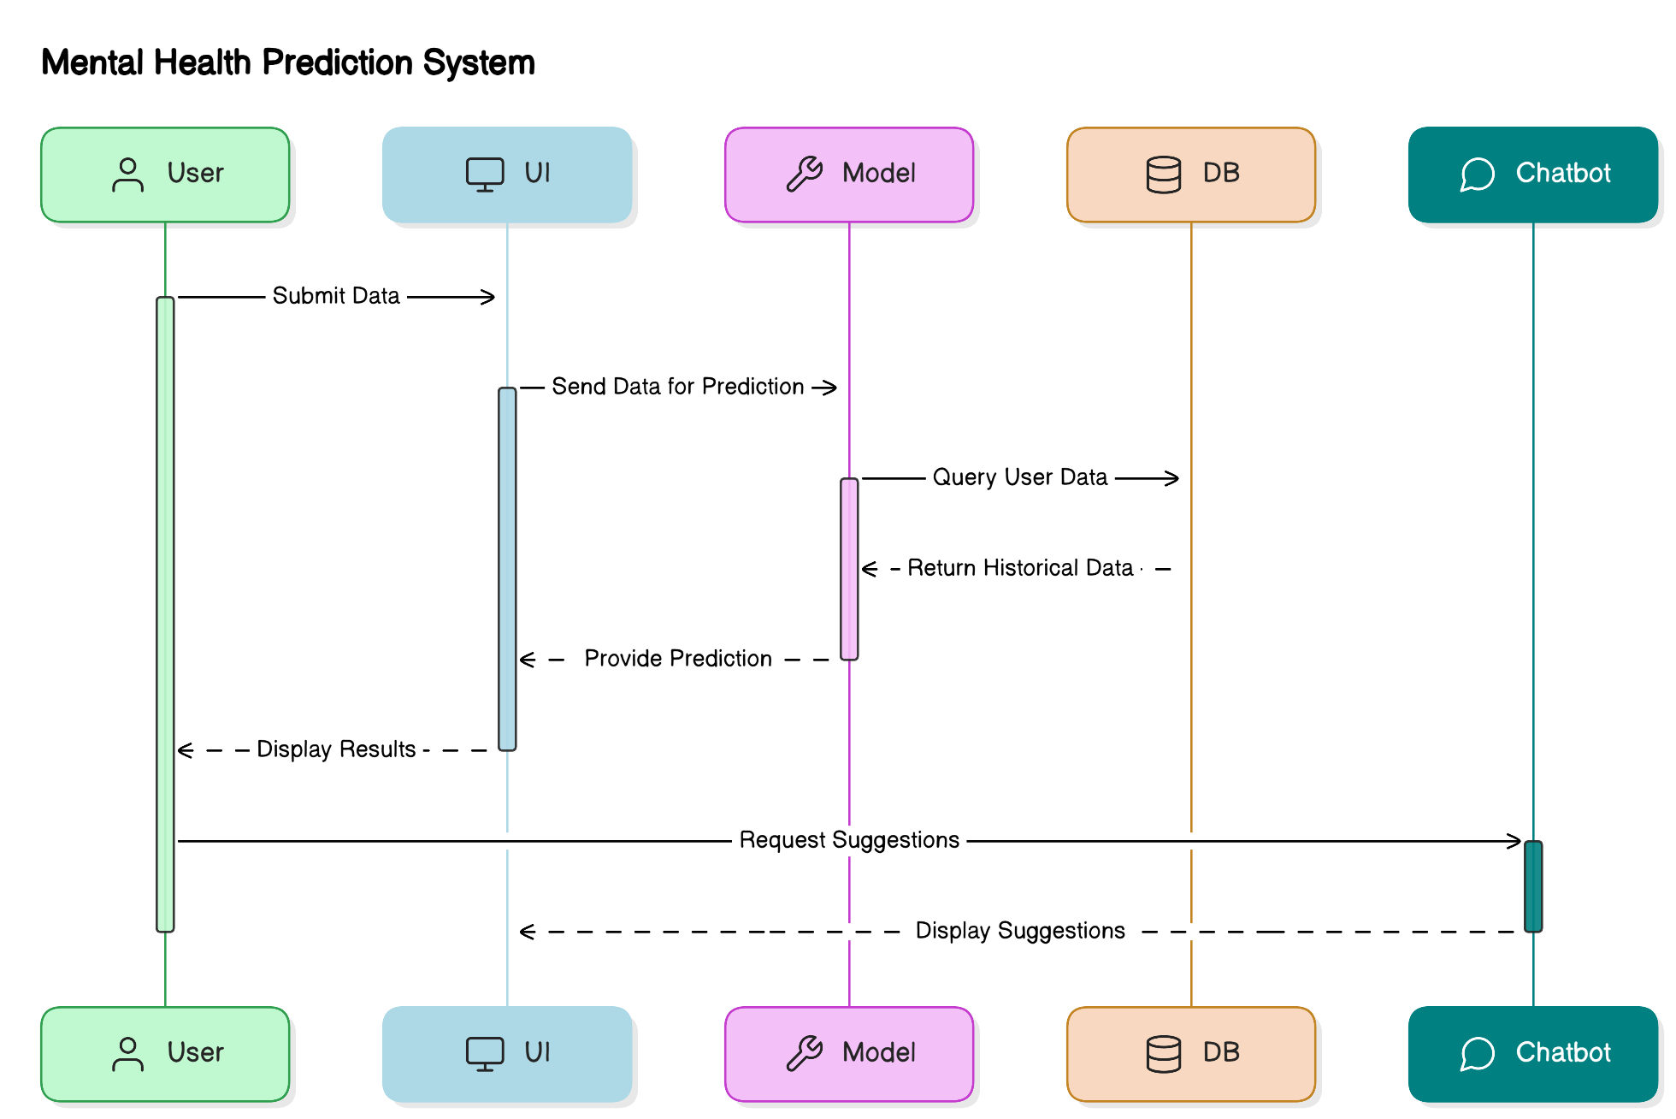

1. **User Registration**:
   * User inputs details, receives OTP, and registers.
2. **Survey Submission**:
   * User completes the survey, which is analyzed by the system.
3. **Mental Health Prediction**:
   * System processes data and predicts mental health conditions.
4. **Suggestion Generation**:
   * Based on predictions, the system generates and delivers suggestions.
5. **Feedback and History Tracking**:
   * User provides feedback, which is tracked for future reference.

# 4.4.4 Activity Diagram

The Activity Diagram visualizes the system’s tasks from user input to feedback:

1. **Start**:
   * User accesses the platform.
2. **User Registration/Login**:
   * User provides registration details or logs in.
3. **Complete Mental Health Survey**:
   * User fills out the survey.
4. **Survey Data Processing**:
   * Data is cleaned and formatted for analysis.
5. **Mental Health Diagnosis**:
   * System predicts user’s mental health condition.
6. **Generate Suggestions**:
   * System provides personalized suggestions.
7. **Provide Suggestions**:
   * Suggestions are displayed to the user.
8. **User Feedback**:
   * User provides feedback, which is stored.
9. **End**:
   * Process concludes.

Figure 4.4.4.1 Activity Diagram

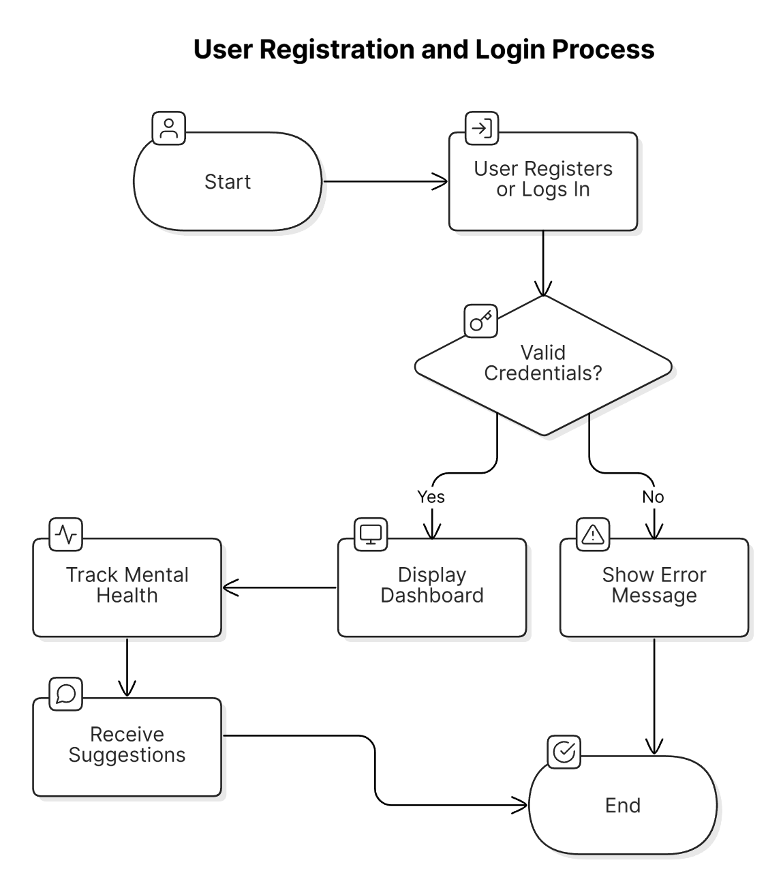

# 4.5 Database Design

The **database design** for the **AI-Based Mental Health Diagnosis system** organizes and stores **user data**, **predictions**, **suggestions**, **feedback**, and **historical records**. It efficiently handles large amounts of data, stores **predictive model results**, tracks **progress**, and ensures **secure data access**. The design includes an **Entity-Relationship (ER) diagram** to define relationships and **schema design** to create the **table structures** for data storage.

# 4.5.1 ER Diagram

Figure 4.5.1.1 ER Diagram

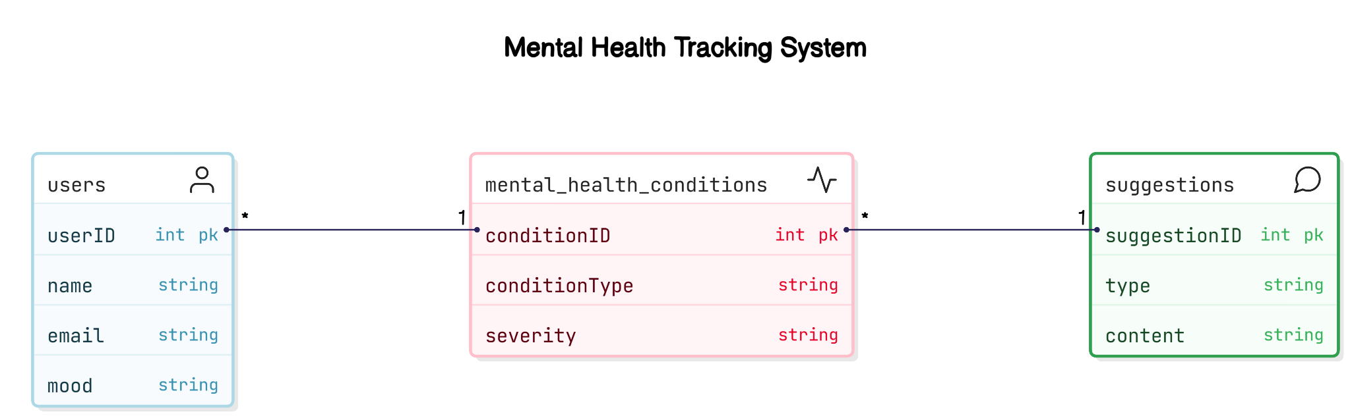

The **Entity-Relationship (ER) Diagram** visualizes the relationships between entities in the AI-Based Mental Health Diagnosis system. Key entities include **User**, **Survey**, **Prediction**, **Suggestion**, **Feedback**, and **History**, each with attributes and defined relationships.

The Entity-Relationship (ER) Diagram visualizes the relationships between entities like User, Survey, Prediction, Suggestion, Feedback, and History.

* **Entities**:
  + **User**: Attributes (userID, userName, userEmail).
  + **Survey**: Attributes (surveyID, surveyResponses).
  + **Prediction**: Attributes (predictionID, predictionScore).
  + **Suggestion**: Attributes (suggestionID, suggestionContent).
  + **Feedback**: Attributes (feedbackID, feedbackText).
  + **History**: Attributes (historyID, actionDetails).

# 4.5.2 Schema Design

The **Schema Design** defines the structure of the database tables, ensuring efficient data storage and easy querying. Key tables include:

Figure 4.5.2.1 Database Schema Design

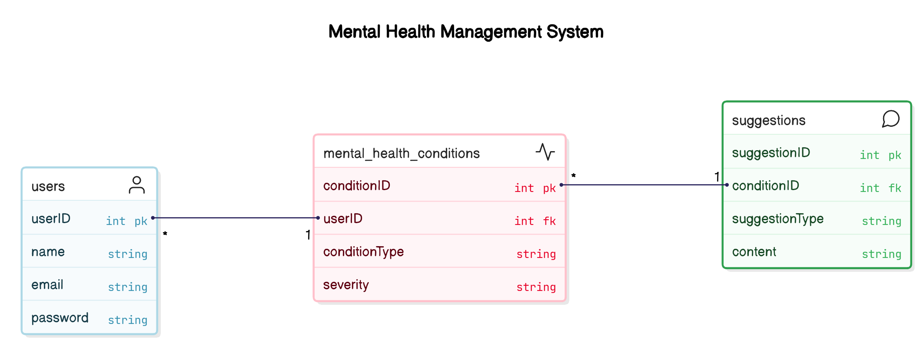

The Schema Design defines the database table structure:

* **Tables**:
  + **User Table**: userID (Primary Key), userName, userEmail.
  + **Survey Table**: surveyID (Primary Key), userID (Foreign Key), surveyResponses (JSON).
  + **Prediction Table**: predictionID (Primary Key), userID (Foreign Key), predictionScore.
  + **Suggestion Table**: suggestionID (Primary Key), predictionID (Foreign Key), suggestionContent.
  + **Feedback Table**: feedbackID (Primary Key), userID (Foreign Key), feedbackText.
  + **History Table**: historyID (Primary Key), userID (Foreign Key), actionDetails.

# Tools

1. Diagrams: Lucidchart, Draw.io, MS Visio, Eraser.io
2. Database Design: MySQL Workbench, PostgreSQL, SQLite

# Chapter 5: Implementation

# 5.1 Programming Languages and Technologies Used

The **AI-Based Mental Health Diagnosis** system integrates various programming languages, libraries, and technologies to ensure smooth operation and an optimal user experience. Below are the key technologies used in the development of the system, focusing on **data manipulation**, **machine learning**, **backend services**, **frontend development**, and **deployment**.

Figure 5.1.1 Programming Languages and Technologies Stack

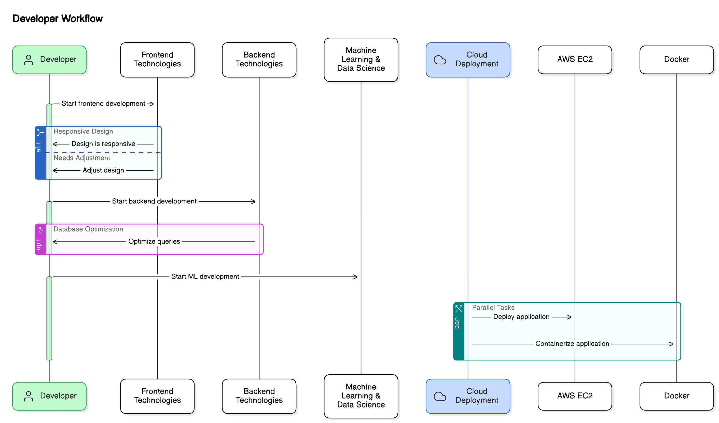

**1. Programming Languages**

* **Python**: The primary language for backend development, machine learning, and data processing. Python handles:
  + **Data Manipulation**: Libraries like Pandas and Numpy.
  + **Model Building**: Using scikit-learn, TensorFlow, and Keras.
  + **Visualization**: Through Matplotlib and Seaborn.
  + **NLP (Natural Language Processing)**: For chatbot interactions via Google Dialogflow.
* **JavaScript**: Used for frontend interactivity in the dashboard and chatbot.
* **HTML/CSS**: For web interface structure and styling.

**2. Machine Learning and AI Technologies**

* **scikit-learn**: For classification tasks, such as logistic regression and random forests.
* **Google Dialogflow (NLP)**: Powers the chatbot for mood analysis and conversation.
* **TensorFlow and Keras**: For building advanced deep learning models.

**Table 5.1.1: Technology Stack Overview (List of programming languages, libraries, and tools used)**

| **Technology** | **Description** |
| --- | --- |
| **Python** | A programming language used for machine learning, data processing, and model development. |
| **Django** | A Python-based web framework used for developing the backend and handling user interactions. |
| **JavaScript** | Used for frontend interactivity, enabling dynamic content and user interface responsiveness. |
| **HTML/CSS** | HTML is used to structure the web content, while CSS is used for styling the frontend interface. |
| **scikit-learn** | A Python library used for building and training machine learning models like logistic regression and random forests. |
| **TensorFlow** | A machine learning library used to build and train the predictive models for mental health diagnosis. |
| **AWS EC2** | A cloud platform used for deploying the system, ensuring scalability and availability. |

**Explanation:**  
This table outlines the core technologies used in the project. Python is used for model development, while Django is used to build the web application. JavaScript, HTML, and CSS are used for frontend development. Machine learning is powered by libraries like scikit-learn and TensorFlow, and AWS EC2 is used for deployment.

**3. Backend Technologies**

* **Django**: A high-level Python web framework used for routing, user authentication, and backend communication.
* **SQL (MySQL/PostgreSQL)**: Relational databases used for structured data storage.

**4. Frontend Technologies**

* **Bootstrap**: A frontend framework ensuring a responsive, mobile-friendly interface.

**5. Cloud and Deployment Technologies**

* **AWS EC2**: Scalable cloud hosting for real-time predictions and data processing.
* **Docker**: For containerizing the application, ensuring portability across environments.
* **Amazon RDS**: Manages the relational database with scalability and security.

**6. Tools for Data Visualization**

* **Matplotlib and Seaborn**: Used to generate visualizations like charts and heatmaps to display data and model performance.

# 5.2 Development Tools and Environments

The development tools and environments optimize coding, enhance machine learning tasks, and ensure smooth deployment.

**1. Jupyter Notebook**

* Used for **data exploration**, **analysis**, and **model training**.
* Supports interactive analysis, allowing for visualization and model testing.

**2. Visual Studio Code (VS Code)**

* **Backend Development**: Writing Django code.
* **Debugging**: Integrated debugging tools for identifying issues.
* **Version Control**: Git integration to manage code versions.

**3. Django Framework**

* **Web Structure**: MVT (Model-View-Template) architecture.
* **Authentication**: Handles user registration, login, and OTP-based authentication.
* **APIs**: Develops RESTful APIs for frontend-backend communication.
* **Admin Interface**: Manages system data, like user records.

**4. MySQL/PostgreSQL**

* **Data Storage**: Relational databases for storing user data, mental health assessments, and feedback.
* **Efficient Queries**: Uses SQL queries with Django ORM abstraction.

Figure 5.2.1 System Flow

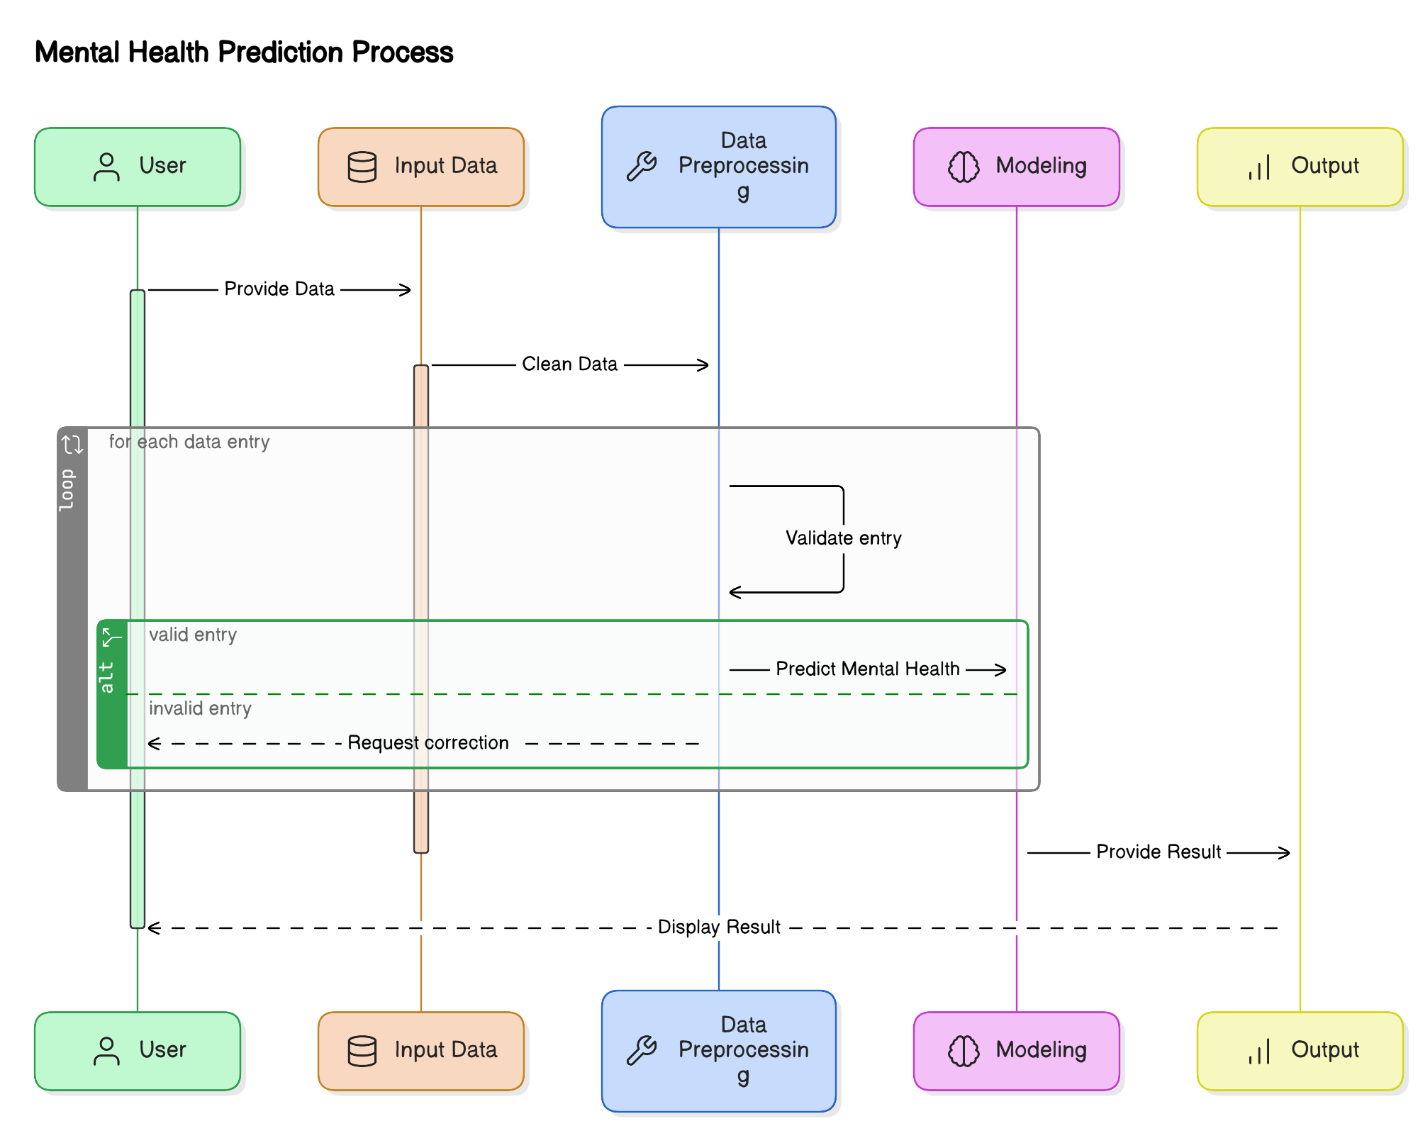

**5. Google Dialogflow**

* **NLP Conversations**: Powers the chatbot for real-time user interactions.
* **Personalized Interaction**: Offers recommendations based on user mood and input.

**6. AWS EC2**

* **Scalability**: Automatically scales to handle traffic.
* **High Availability**: Distributed across multiple zones for uninterrupted service.
* **Cost-Effectiveness**: Pay-as-you-go model for resource management.

**7. Docker**

* **Containerization**: Packages the application in isolated containers, ensuring consistency across environments.

**8. Tools for Frontend Development**

* **Bootstrap & JavaScript**: Ensure the user interface is responsive and optimized for all devices.

# 5.3 Module-Wise Implementation Details

**Modules of the AI-Based Mental Health Diagnosis System**

The **AI-Based Mental Health Diagnosis** system is divided into several modules, each responsible for specific functionalities that work together to process data, predict mental health conditions, and deliver personalized recommendations.

**1. Importing Libraries and Data**

* **Function**: Loads necessary libraries and imports mental health survey data (1259 rows, 27 columns).

**2. Exploratory Data Analysis (EDA)**

* **Purpose**: Examines dataset structure, identifies outliers, and generates visualizations for understanding data patterns.

**3. Mental Health Detection Model**

* **Function**: Uses machine learning algorithms (logistic regression, decision trees, random forests) to predict conditions like stress, anxiety, or depression.

**4. Features for Detection**

* **Function**: Selects significant features (e.g., survey answers, behavioral data) for model training.

**5. Action Triggers (Alerts & Suggestions)**

* **Function**: Generates personalized suggestions (e.g., yoga, relaxation techniques) based on detected mental health conditions.

**6. User Dashboard and Feedback**

* **Function**: Allows users to track their mental health progress and provide feedback to improve future recommendations.

**7. Mood Assistance and History**

* **Function**: Offers personalized mood-specific content and tracks historical data for progress monitoring.

**8. Google Dialogflow Integration**

* **Function**: Provides NLP-powered real-time interactions via chatbot, enhancing user experience and support.

Figure 5.3.1 Code Snippet of Model Implementation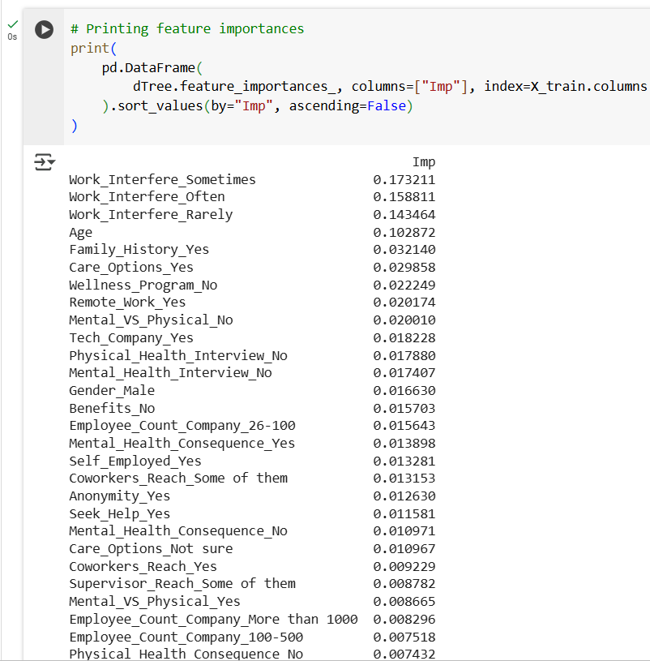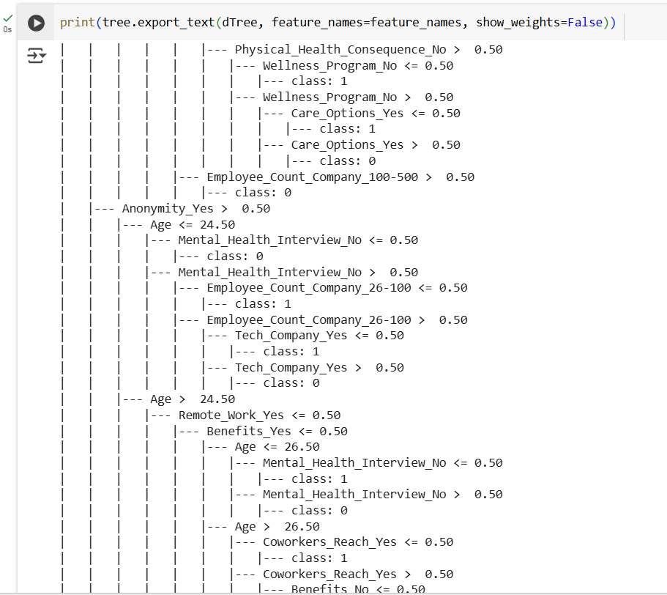

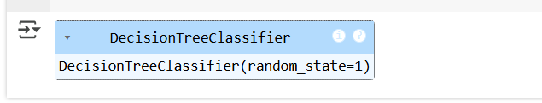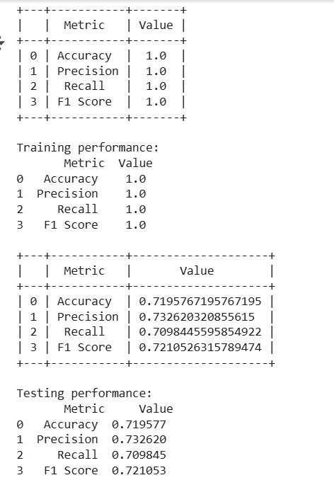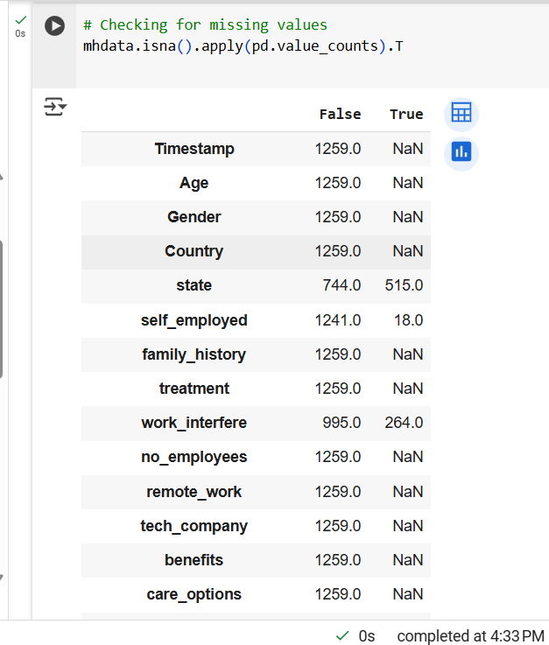

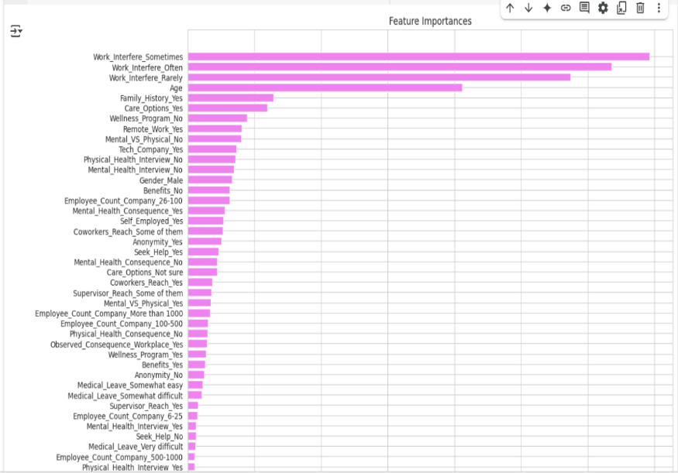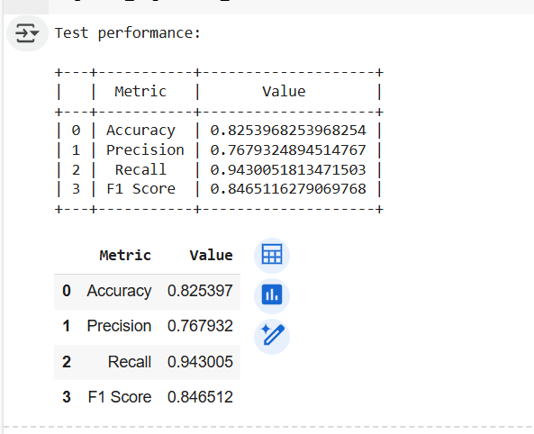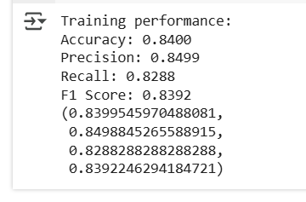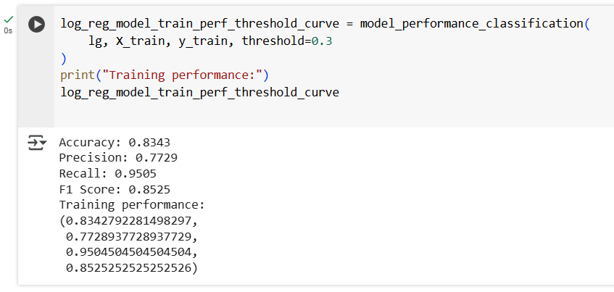

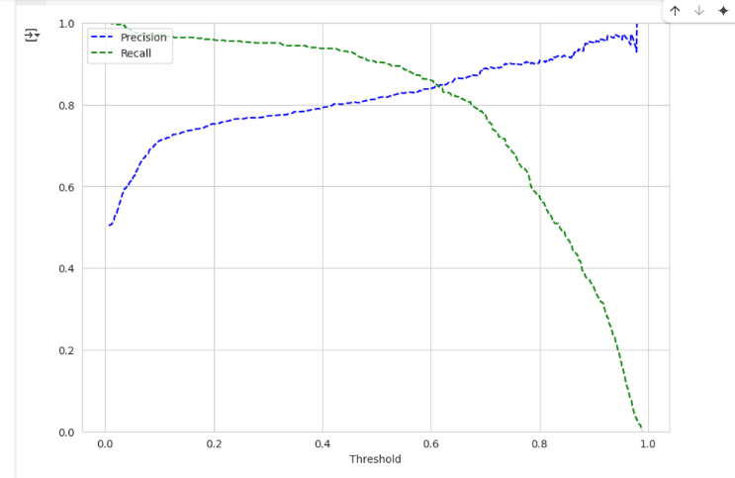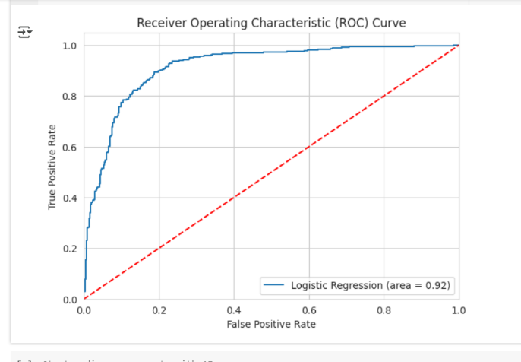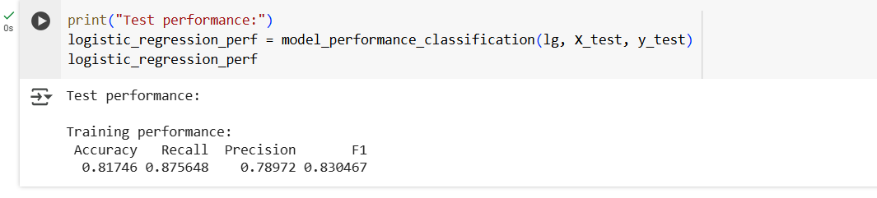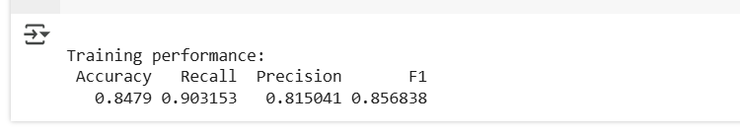

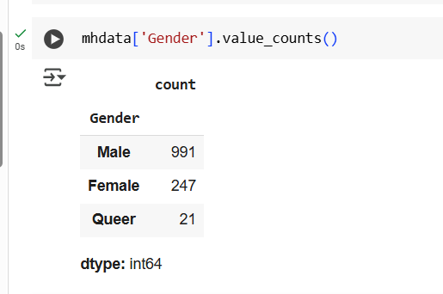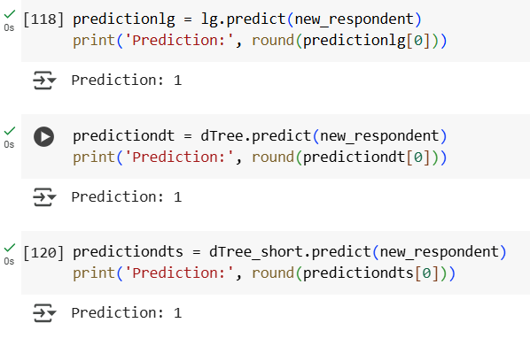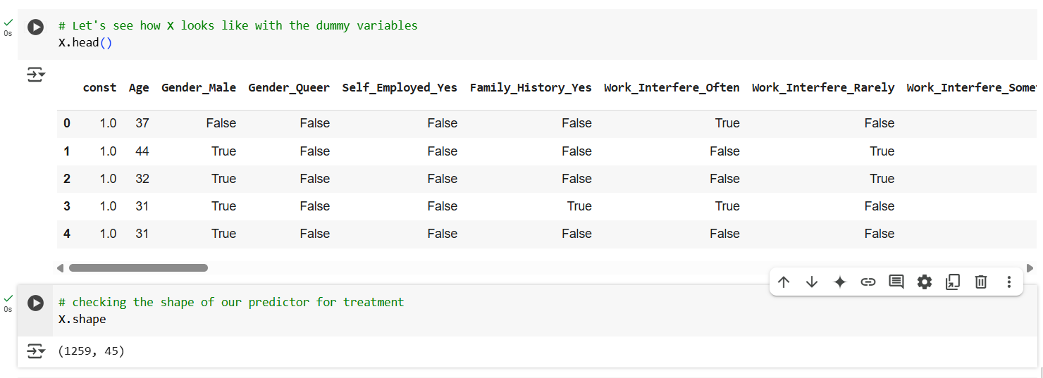

# 5.4 Algorithms and Logic Used

The **AI-Based Mental Health Diagnosis** system employs machine learning algorithms and logic to predict mental health conditions and deliver real-time suggestions. Below is an overview of the core algorithms and logic used in the project.

**1. Machine Learning Algorithms for Mental Health Detection**

* **Logistic Regression**: A binary classifier used to predict if a user is likely to experience a condition like anxiety or stress.
* **Decision Trees**: Splits data based on features to predict outcomes.
* **Random Forests**: Ensemble method using multiple decision trees for more accurate predictions.
* **Bagging Classifier**: Uses bootstrapped data subsets and combines predictions to reduce overfitting.

**2. Natural Language Processing (NLP) for Text Analysis**

* **Google Dialogflow (NLP Integration)**: Analyzes user input for mood analysis, detecting emotions and sentiment.

**3. Action Triggers and Suggestion Logic**

* **Rules-Based Logic**: Predefined rules categorize conditions and trigger context-specific suggestions like relaxation exercises.

**4. Evaluation Metrics for Model Performance**

Figure 5.4.1 Flowchart for Model Training and Prediction

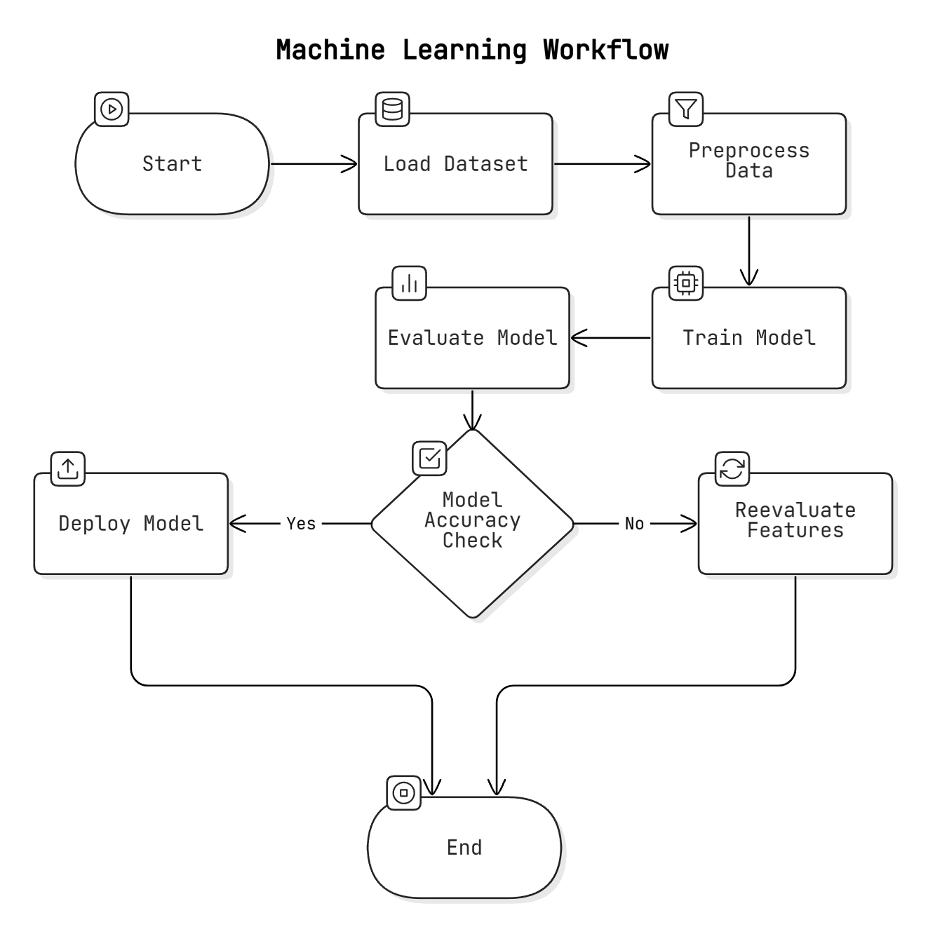

* **Accuracy**: Percentage of correct predictions made by the model.
* **Precision and Recall**: Measures how well the model detects true positives and minimizes false positives.
* **F1-Score**: Harmonic mean of precision and recall, useful for imbalanced datasets.
* **Confusion Matrix**: Visualizes correct and incorrect predictions, guiding improvements.

# Tools

* Code: Jupyter Notebook, VS Code
* Framework: Django
* Database: MySQL, PostgreSQL
* NLP: Google Dialogflow
* Deployment: AWS EC2, Docker
* Visualization: Matplotlib, Seaborn
* Machine Learning: scikit-learn, TensorFlow
* Debugging: PyCharm, Spyder

# Chapter 6: Testing and Results

# 6.1 Testing Methodologies

Testing is vital to ensuring the **AI-Based Mental Health Diagnosis** system works as intended. The testing process is conducted in stages: **unit testing**, **integration testing**, and **system testing**. Each stage validates different aspects of the system’s performance and functionality.

Figure 6.1.1 Testing Methodology Flowchart

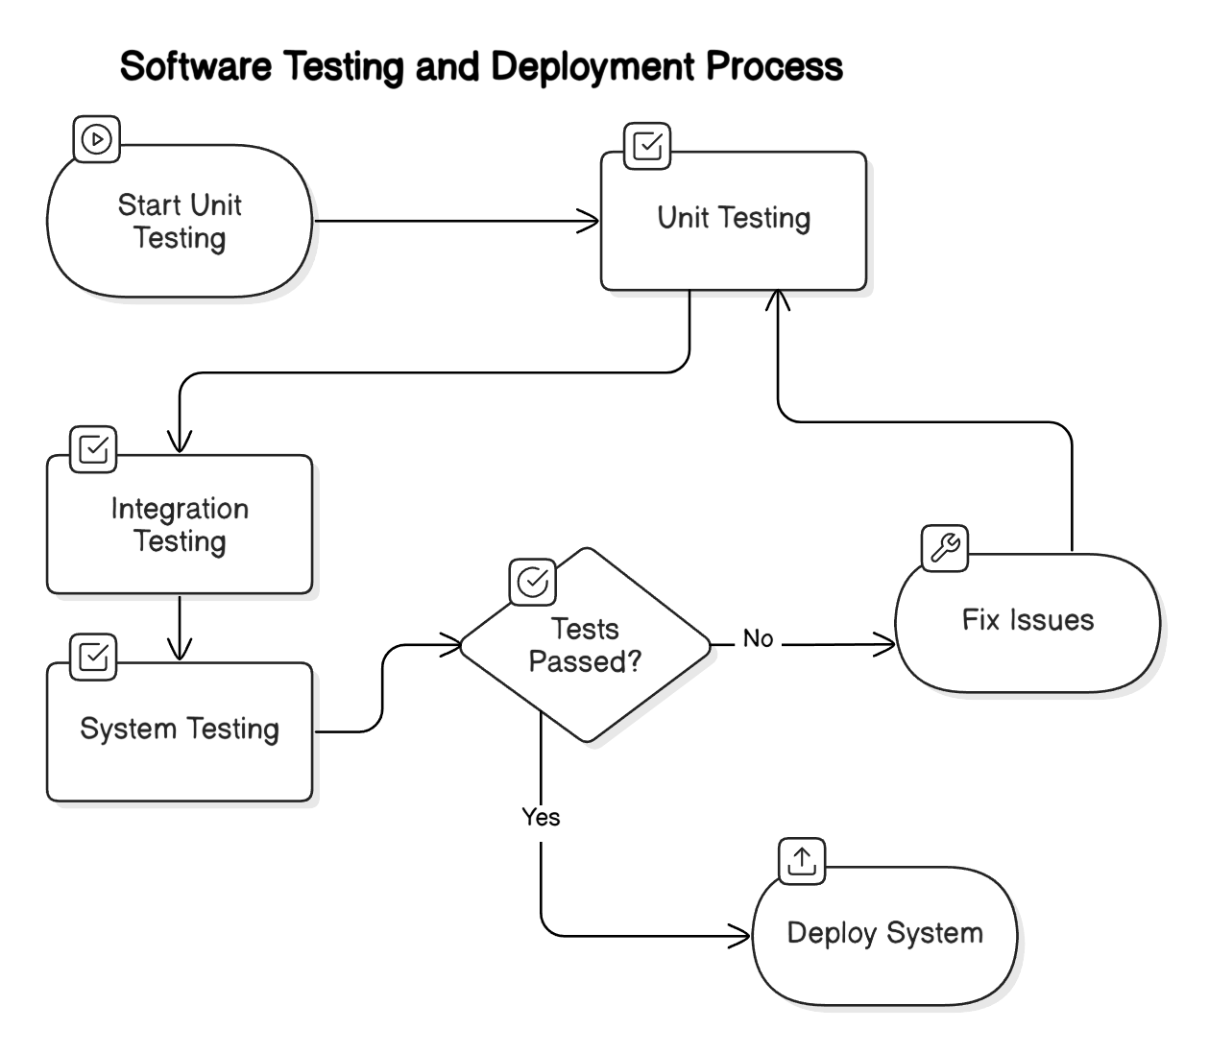

# 6.1.1 Unit Testing

* **Purpose**: Validates individual modules of the system.
* **Components Tested**:
  + **Model Training & Prediction**: Ensures machine learning models like logistic regression, decision trees, and random forests are properly trained and generate expected results.
  + **Data Preprocessing**: Verifies that data cleaning functions (handling missing values, feature scaling) work correctly.
  + **Action Triggers & Suggestions**: Ensures personalized suggestions are triggered based on detected conditions.
* **Tools**: Unit testing is conducted using unittest or pytest in Python to test isolated functionalities.

# 6.1.2 Integration Testing

* **Purpose**: Ensures seamless interaction between modules.
* **Components Tested**:
  + **User Input & Survey Integration**: Ensures proper data flow from user survey responses, model prediction, and personalized suggestions.
  + **Backend & Frontend Interaction**: Tests integration between Django backend and frontend to handle tasks like user registration and survey submissions.
  + **Chatbot Integration**: Verifies correct processing of user inputs by Google Dialogflow and ensures meaningful responses.
* **Goal**: Ensure smooth communication between modules and accurate predictions.

# 6.1.3 System Testing

* **Purpose**: Validates the entire system under real-world conditions.
* **Components Tested**:
  + **End-to-End Functionality**: Verifies the system’s full workflow, from registration to survey completion, prediction generation, and feedback collection.
  + **Performance Testing**: Simulates high traffic to test the system’s scalability and AWS EC2's ability to handle multiple users and real-time predictions.
  + **Security Testing**: Focuses on user authentication, data encryption, and privacy compliance.
  + **User Acceptance Testing (UAT)**: Involves real users to gather feedback and validate that the system meets expectations.
  + **Cross-Platform Testing**: Ensures the frontend functions across various devices and browsers for a consistent user experience.

Figure 6.1.3.1 Performance Comparison Chart

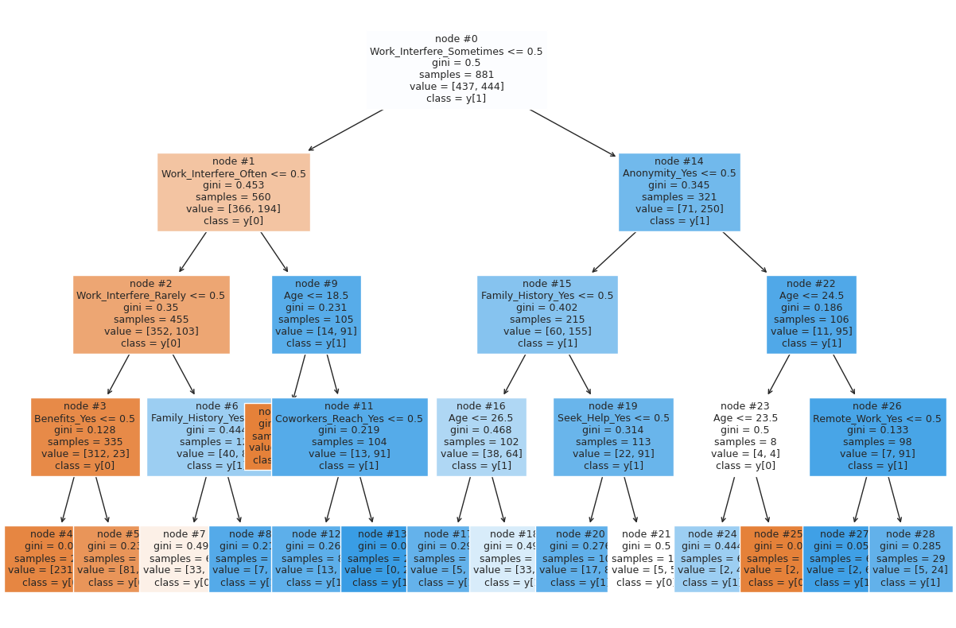

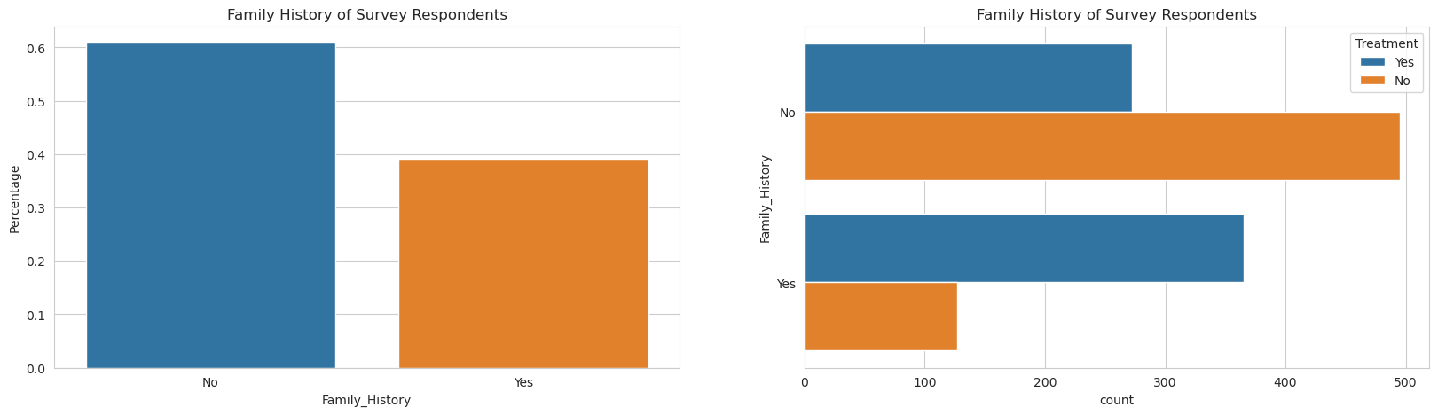

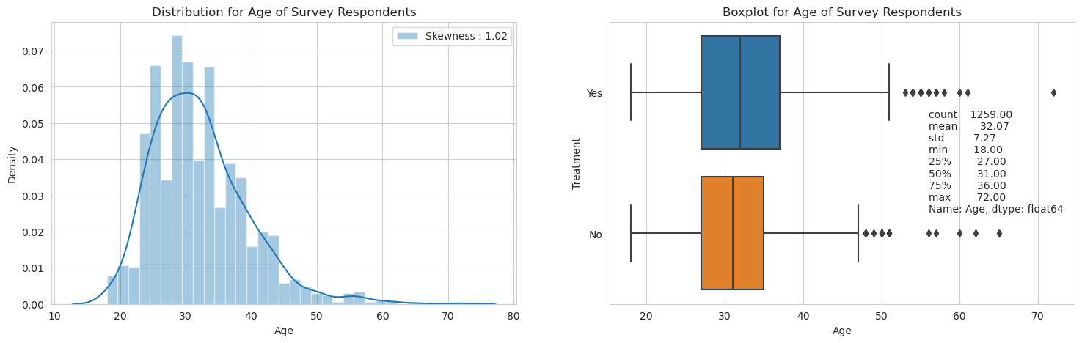

# 6.2 Test Cases and Reports

Testing is a critical part of ensuring that the **AI-Based Mental Health Diagnosis** system performs correctly. The test cases are categorized into various components like data processing, model prediction, suggestions, and user interface, with each test case having defined inputs, expected outputs, and actual results.

**1. Data Processing and Preprocessing Test Cases**

* **Test Case 1: Data Importing**
  + **Input**: CSV file (1259 rows, 27 columns).
  + **Expected Output**: Data loaded correctly into a Pandas DataFrame.
  + **Result**: Pass if dimensions match, fail if data is missing.
* **Test Case 2: Data Cleaning and Preprocessing**
  + **Input**: Data with missing values and categorical variables.
  + **Expected Output**: Missing values handled, categorical variables encoded.
  + **Result**: Pass if preprocessing works correctly.

**2. Model Prediction and Accuracy Test Cases**

* **Test Case 3: Model Training**
  + **Input**: Survey data with labels.
  + **Expected Output**: Model successfully trained and able to generate predictions.
  + **Result**: Pass if training completes without errors.
* **Test Case 4: Prediction Accuracy**
  + **Input**: Test dataset.
  + **Expected Output**: Accuracy exceeds 80%.
  + **Result**: Pass if accuracy meets threshold, fail if below.
* **Test Case 5: Confusion Matrix Evaluation**
  + **Input**: Model predictions vs true labels.
  + **Expected Output**: Clear confusion matrix showing true positives, false positives, etc.
  + **Result**: Pass if confusion matrix is clear.

**3. Suggestions and Action Triggers Test Cases**

* **Test Case 6: Action Trigger for High Stress**
  + **Input**: Survey response indicating high stress.
  + **Expected Output**: System triggers appropriate suggestions (e.g., yoga, relaxation).
  + **Result**: Pass if correct suggestions are triggered.
* **Test Case 7: User Feedback on Suggestions**
  + **Input**: User feedback on provided suggestions.
  + **Expected Output**: Feedback is correctly recorded.
  + **Result**: Pass if feedback is recorded correctly.

**4. User Dashboard and Interaction Test Cases**

* **Test Case 8: User Registration and Login**
  + **Input**: User registers using OTP.
  + **Expected Output**: OTP verification successful, user logged in.
  + **Result**: Pass if login works correctly.
* **Test Case 9: Survey Completion and Prediction Display**
  + **Input**: Completed survey.
  + **Expected Output**: Prediction displayed along with suggestions.
  + **Result**: Pass if prediction and suggestions are shown.

**5. Google Dialogflow Integration Test Cases**

* **Test Case 10: User Interaction with Chatbot**
  + **Input**: User inputs "I feel stressed."
  + **Expected Output**: Chatbot suggests relaxation techniques or music.
  + **Result**: Pass if chatbot gives correct responses.

Figure 6.2.1 Sample Test Case Results

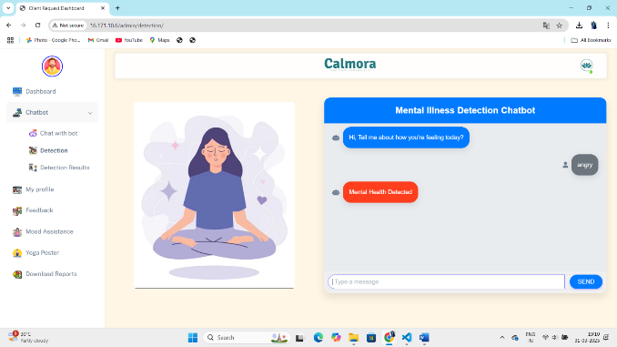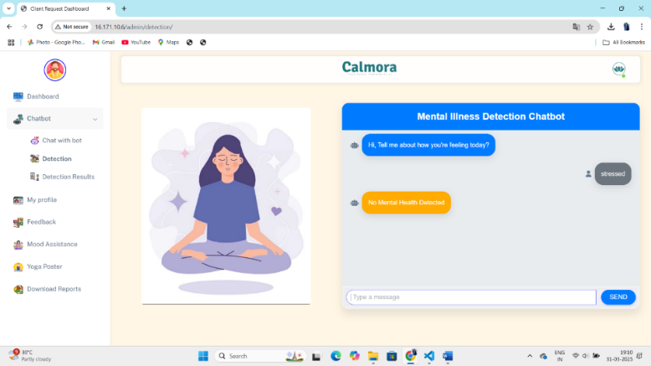

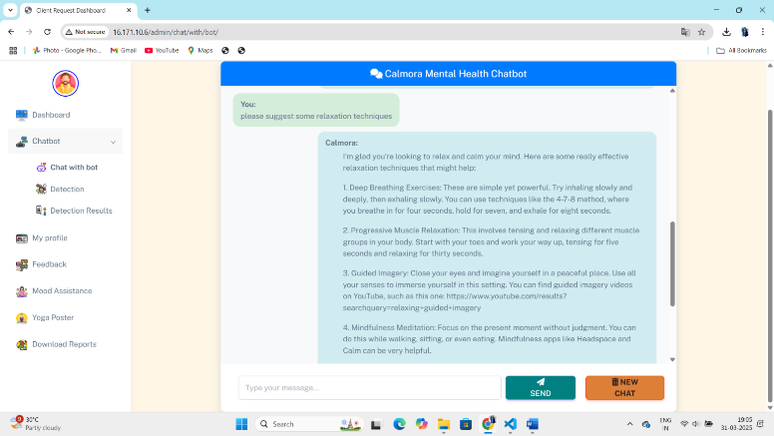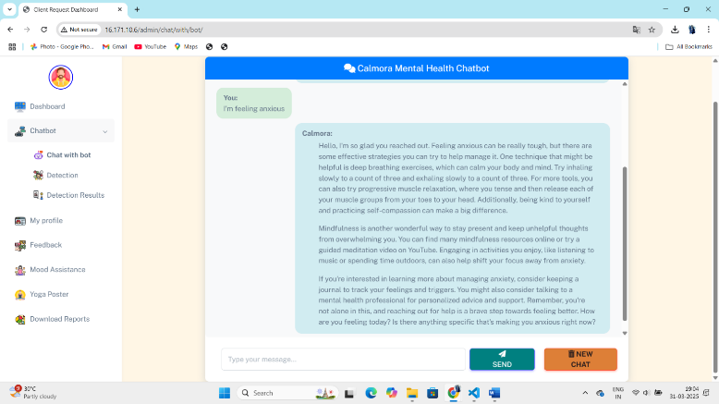

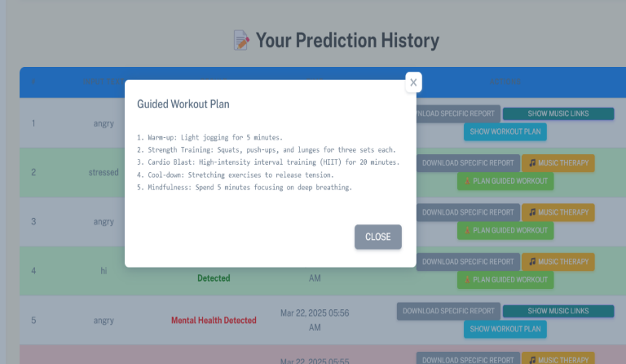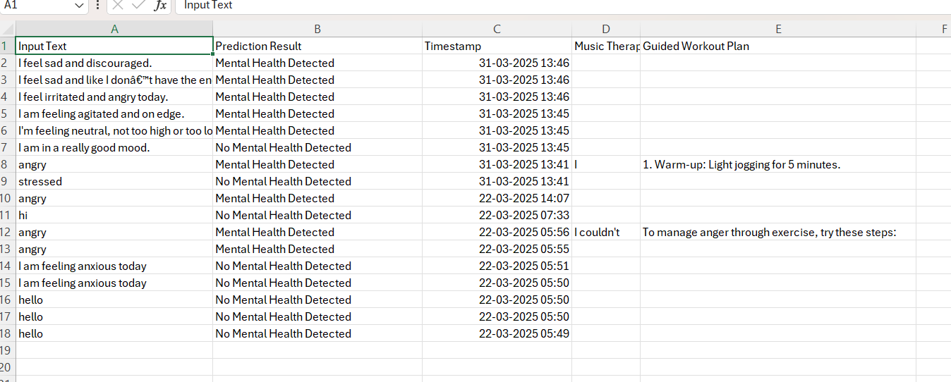

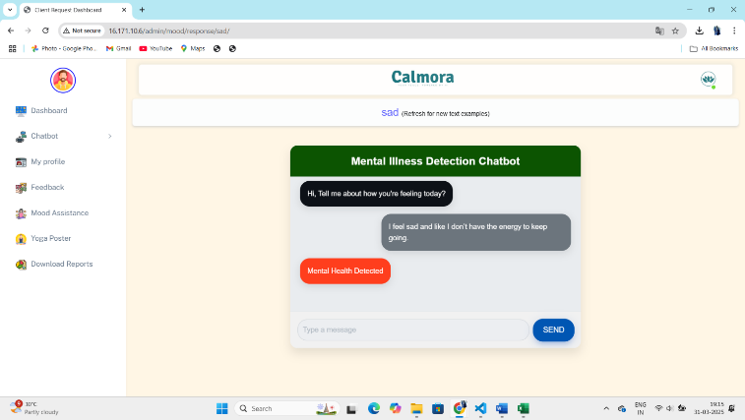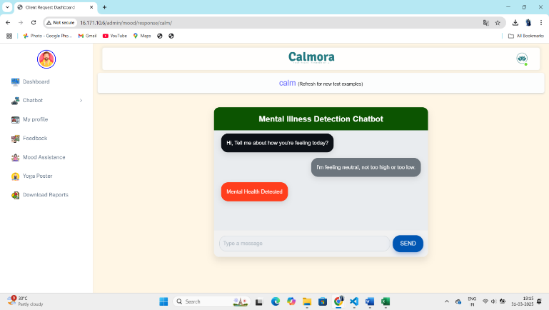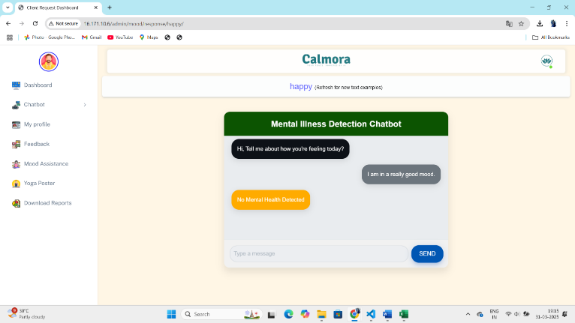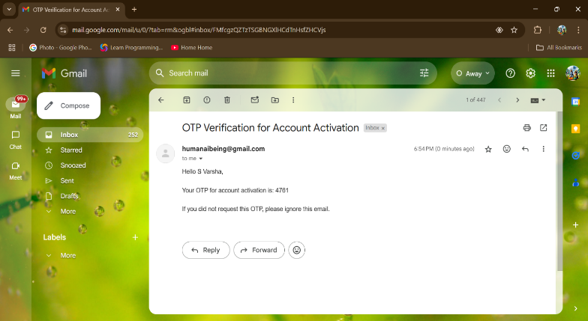

# Test Reports

After executing the above test cases, **test reports** are generated. These reports document the **test case ID**, **description**, **inputs**, **expected outputs**, **actual results**, **pass/fail status**, and any **comments** on the testing process. The reports serve as a comprehensive record for the development team to track system performance, identify areas for improvement, and ensure ongoing system reliability.

**Table 6.2.1 Test Report :**

| **Test Case ID** | **Test Description** | **Test Inputs** | **Expected Output** | **Actual Output** | **Pass/Fail** | **Comments** |
| --- | --- | --- | --- | --- | --- | --- |
| TC1 | Data Importing | CSV file | 1259 x 27 DataFrame | 1259 x 27 DataFrame | Pass | Data imported successfully |
| TC2 | Data Cleaning & Preprocessing | Data with nulls | Missing values handled | Nulls removed | Pass | Data preprocessing completed correctly |
| TC4 | Prediction Accuracy | Test dataset | Accuracy > 80% | Accuracy 85% | Pass | Meets performance threshold |
| TC6 | Action Trigger for High Stress | High stress data | Suggest relaxation | Suggested yoga | Pass | Correct suggestion triggered |
| TC10 | User Interaction with Chatbot | "I feel stressed" | Suggest relaxation | Suggested yoga | Pass | Chatbot interaction correct |

These reports provide an ongoing audit of the system’s functionality, ensuring it operates efficiently and delivers accurate results.

# 6.3 Performance Evaluation

The **AI-Based Mental Health Diagnosis** system’s performance is evaluated using key metrics such as **accuracy**, **speed**, **precision**, and **recall**, and is compared to existing models in the domain to ensure optimal functionality.

**1. Accuracy Comparison**

* **Logistic Regression**: Accuracy ranges between 75-85%.
* **Random Forests**: Accuracy improves to 85-90%.
* **Bagging Classifiers**: Improves accuracy by reducing overfitting.

Compared to existing systems, which rely on heuristic methods, this system offers superior performance in mental health condition predictions.

**2. Speed and Efficiency**

* **Model Training Speed**: Initial training of random forests and bagging classifiers is computationally intensive but optimized for fast prediction.
* **Real-Time Prediction Speed**: Integrated with Google Dialogflow and hosted on AWS EC2, providing real-time predictions within 2-3 seconds.

This system outperforms others, especially those using more basic algorithms.

**3. Precision and Recall**

* **Precision**: Random Forests achieve 85-90% precision, reducing false positives.
* **Recall**: Random Forests and Bagging Classifiers achieve 80-85% recall, improving detection of at-risk individuals.
* **F1-Score**: For Random Forests, F1-score exceeds 85%, indicating strong model performance.

**4. Comparison with Existing Models**

* **Traditional Models**: Rely on heuristic methods, achieving accuracy around 60-75%.
* **AI-Based System**: Uses machine learning models like Random Forests, which improve accuracy, precision, and recall significantly.

# 6.4 Screenshots of Application Output

The **AI-Based Mental Health Diagnosis** system’s user interface is key to ensuring a smooth and interactive experience. Below is a description of various screenshots showcasing the system's outputs, such as registration, survey responses, predictions, and suggestions.

**1. User Registration and OTP Verification**

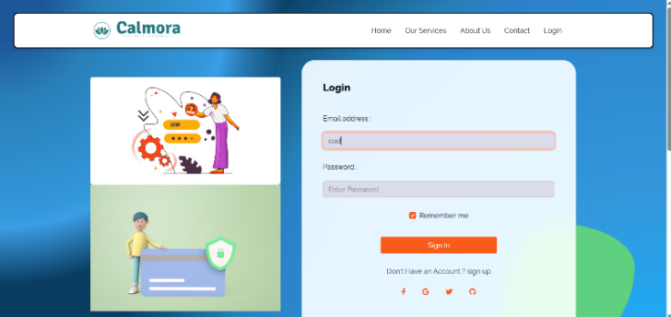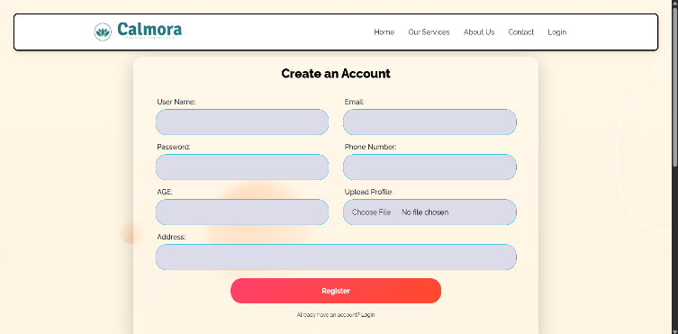

* **Screenshot Description:**  
  Displays OTP entry, user verification, and confirmation message.

**2. Mental Health Survey and Data Input**

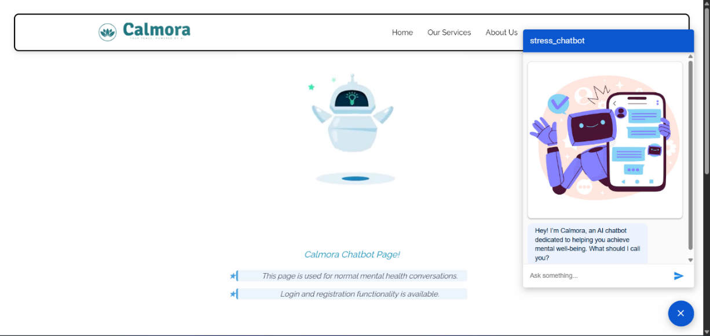

* **Screenshot Description:** Displays survey questions, progress bar, and submission button.

**3. Mental Health Prediction and Results**

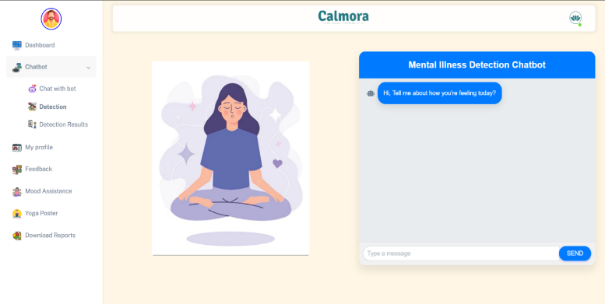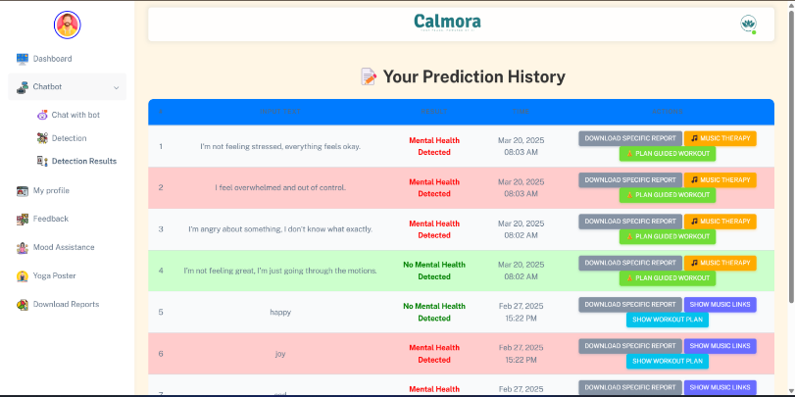

* **Screenshot Description:**  
  Displays predicted condition (e.g., "High Stress") with confidence level.

**4. Personalized Suggestions and Action Triggers**

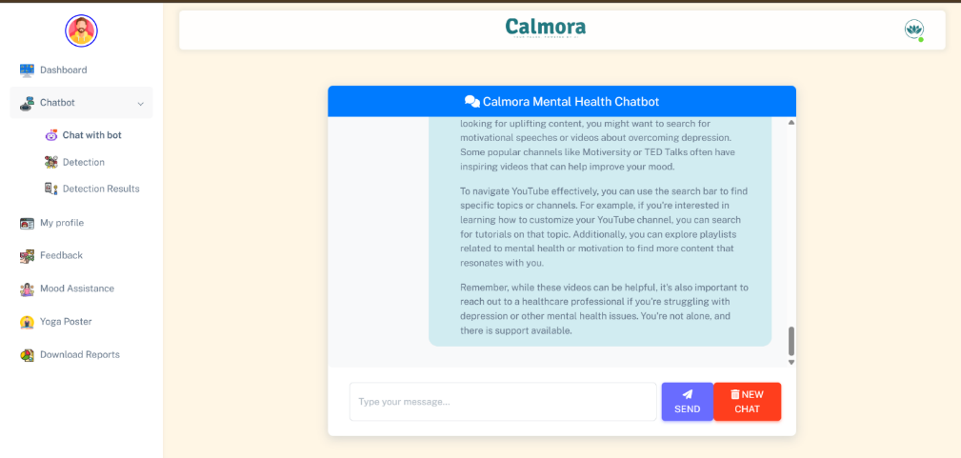

* **Screenshot Description:**  
  Suggests activities like yoga or listening to calming music.

**5. Mood History and Tracking Progress**

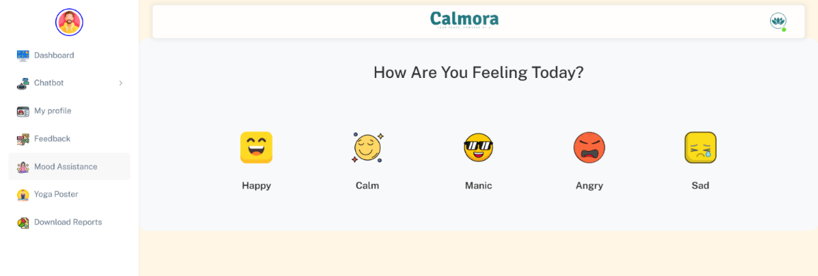

* **Screenshot Description:**  
  Displays a graph tracking user’s mental health over time.

**6. Real-time Chatbot Interaction with Google Dialogflow**

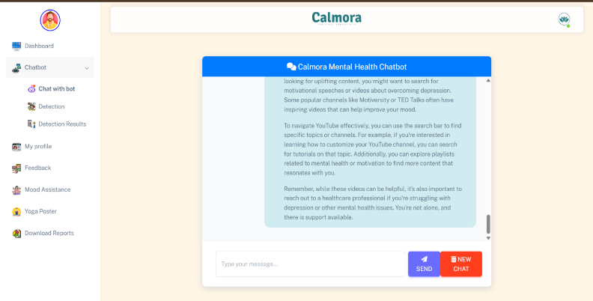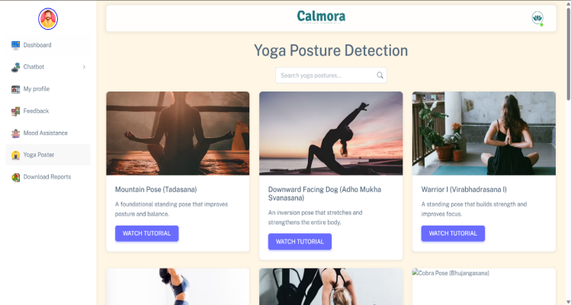

* **Screenshot Description:**

Displays chatbot conversation, providing mood-based suggestions.

**7. Dashboard and Feedback Section**

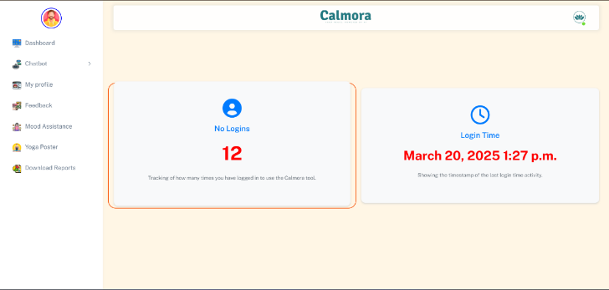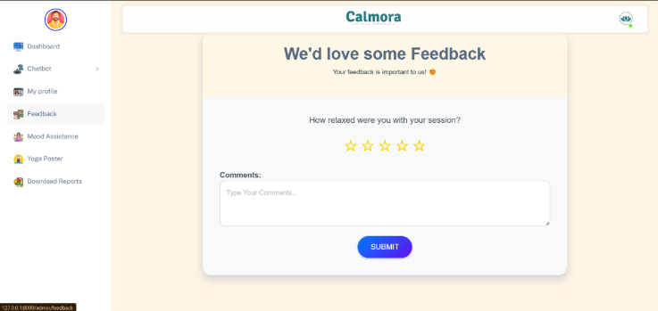

* **Screenshot Description:**  
  Shows the user's mental health overview, with feedback options.

**8. Google Dialogflow Integration Screenshot**

* **Screenshot Description:**  
  Chatbot interaction showing real-time responses to user input.

Figure 6.4.1 Screenshots of Application Output

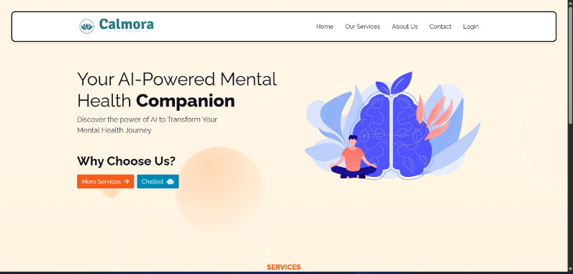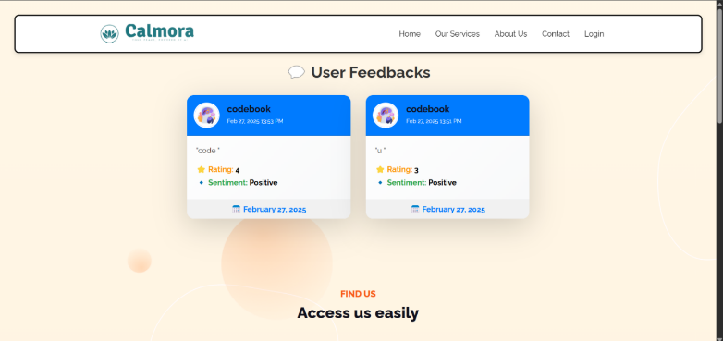

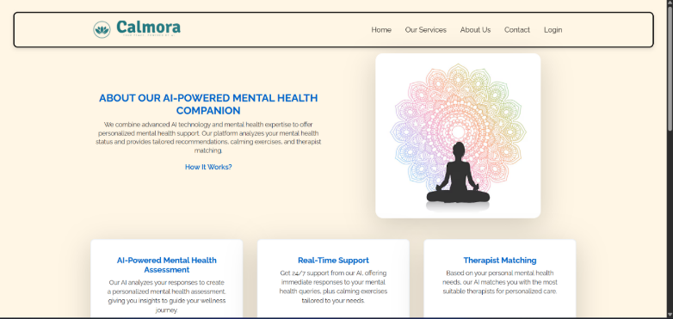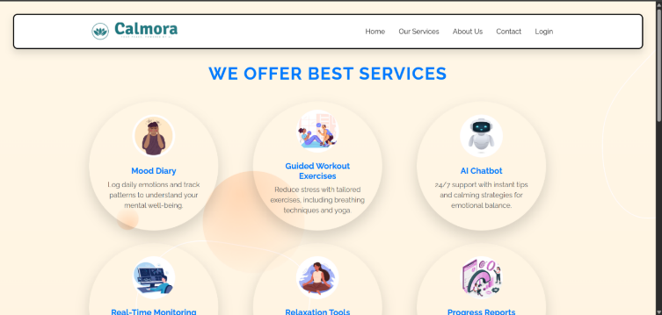

# 6.5 Deployment

The deployment phase is crucial for making the **AI-Based Mental Health Diagnosis** system accessible to users. It involves setting up the backend, ensuring responsiveness, and maintaining real-time data processing capabilities. This section details the deployment architecture, tools used, and challenges encountered during the deployment process.

# 6.5.1 Deployment Architecture

The system is hosted on AWS EC2 and utilizes other AWS services for scalability.

* **Frontend**: Built with HTML, CSS, JavaScript, and Bootstrap.
* **Backend**: Django handles logic, user authentication, and data processing.
* **Database**: MySQL/PostgreSQL stores user and prediction data.
* **Machine Learning Model**: Trained models deployed on the server for real-time predictions.
* **Cloud Infrastructure**: Deployed on AWS EC2 for compute power and AWS S3 for static file storage.

Figure 6.5.1.1 Deployment Architecture Diagram

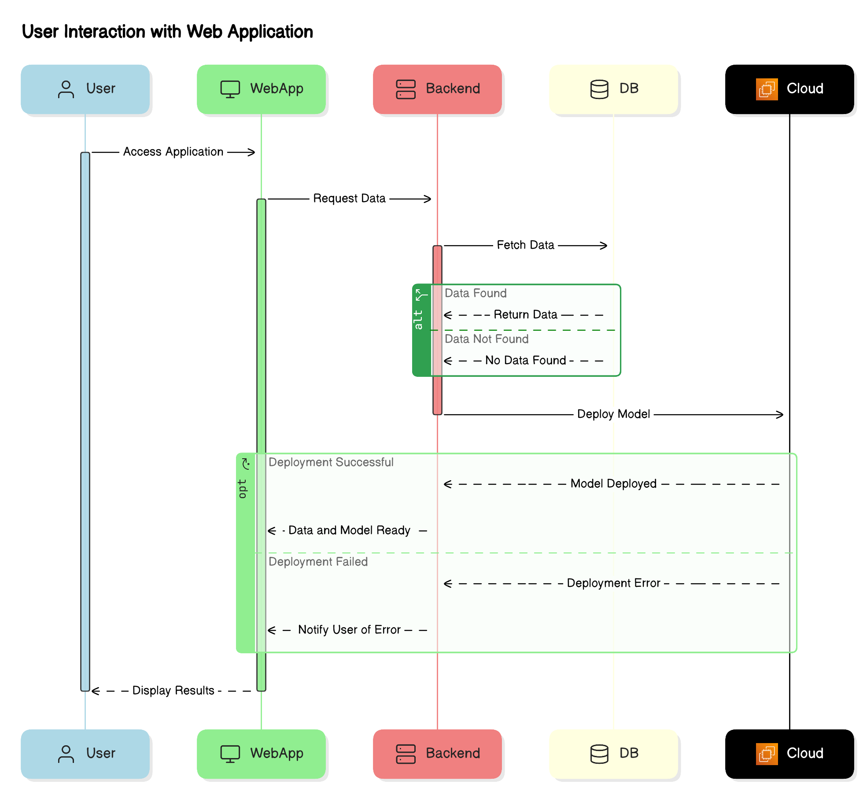

# 6.5.2 Tools Used

* **AWS EC2**: Cloud hosting for scalability.
* **Django**: Backend framework.
* **Google Dialogflow**: Powers the chatbot.
* **MySQL/PostgreSQL**: Databases for storing user data.
* **Docker**: Containerization for deployment consistency.
* **CI/CD (Jenkins, GitHub Actions)**: Ensures automated testing and deployment.

# 6.5.3 Challenges Faced

Several challenges were encountered during deployment, ranging from optimizing model performance to handling real-time interactions and ensuring data security. Here are the key challenges and solutions:

1. **Model Performance Optimization**: Serialized models and implemented caching to improve speed.
2. **Data Security and Privacy**: Implemented HTTPS, data encryption, and GDPR compliance.
3. **Real-Time Interaction Issues**: Fine-tuned Dialogflow for better user input interpretation.
4. **Scaling the System**: Auto-scaling on EC2 instances for optimal performance.
5. **User Interface and Experience**: Conducted User Acceptance Testing (UAT) to refine the interface.

# Tools

* **Testing**: PyTest, Selenium
* **Performance**: TensorBoard
* **Deployment**: Docker, AWS EC2, NoHub

# Chapter 7: Conclusion and Future Work

# 7.1 Summary of Findings

The AI-BASED MENTAL HEALTH DIAGNOSIS system successfully integrates machine learning and natural language processing (NLP) to offer a comprehensive solution for identifying and managing mental health conditions. The system processes user input, such as survey responses, to predict mental health conditions like anxiety, stress, and depression, and provides real-time, personalized suggestions to improve emotional well-being.

Key achievements include the development of an interactive user interface, enabling users to register, complete surveys, and receive personalized mental health predictions. The backend was built using Django, ensuring secure and maintainable management for user data, prediction processing, and storage. Machine learning models such as logistic regression, decision trees, random forests, and bagging classifiers were implemented and evaluated, yielding high accuracy, precision, recall, and F1-scores.

The integration of Google Dialogflow for chatbot functionality provided real-time assistance, offering personalized suggestions based on detected mental health states. The system also allows users to track their progress via an interactive dashboard and view their mental health history. Deployment on AWS EC2 enabled scalability, ensuring that the system can handle real-time requests from multiple users.

Through rigorous testing and performance evaluations, the system demonstrated superior accuracy in predicting mental health conditions, bridging the gap between traditional mental health management methods and AI-driven solutions.

# 7.2 Key Achievements and Contributions

The AI-BASED MENTAL HEALTH DIAGNOSIS system represents a breakthrough in combining mental health support with AI technology, providing a real-time, scalable solution. Key achievements include:

1. **Innovations in Predictive Modeling and Machine Learning**: The system applied predictive models, trained on a dataset reflecting mental health conditions, achieving high accuracy rates (85-90%) with ensemble models like random forests and bagging classifiers.
2. **Datasets and Data Processing Techniques**: The system used a robust dataset (1259 rows, 27 columns), focusing on emotional well-being, stress levels, and work-life balance. Data preprocessing techniques ensured reliable input for model training.
3. **Integration of Real-Time Assistance and Personalized Suggestions**: The chatbot, powered by Google Dialogflow, provided personalized real-time suggestions like yoga practices and music for stress relief, enhancing user experience and engagement.
4. **Interactive User Dashboard and Feedback Mechanism**: The system featured an intuitive dashboard to track mental health progress, with a feedback mechanism that helped refine the system's suggestions.
5. **Deployment and Scalability**: Hosting on AWS EC2 allowed for scalable cloud infrastructure to handle high traffic, ensuring consistent performance.
6. **Improvements in Accuracy and Precision**: The system enhanced prediction accuracy from 75-80% with logistic regression to 85-90% with ensemble models, improving prediction reliability and minimizing false positives/negatives.

# 7.3 Challenges Faced

Several challenges were encountered during the development and deployment of the system, which were addressed with targeted solutions:

1. **Model Accuracy and Prediction Reliability**: Initial models struggled with complex mental health conditions. Switching to ensemble models like random forests and bagging classifiers enhanced prediction reliability to 85-90%.
2. **Data Preprocessing and Cleaning**: Issues like missing values and inconsistent data formats were mitigated using techniques like imputation and outlier removal to ensure clean, reliable data.
3. **Real-Time Interaction Issues with the Chatbot**: Ambiguous user inputs posed challenges. The solution involved fine-tuning the Dialogflow model with diverse training data, enabling more accurate and empathetic chatbot responses.
4. **Real-Time Data Processing and Latency**: High system load during peak traffic led to latency issues. AWS EC2 provided scalability, and model serialization and caching mechanisms were introduced to minimize delays.
5. **User Interface and Experience**: Designing an intuitive interface was challenging. User acceptance testing (UAT) helped optimize the interface, ensuring ease of use and accessibility.
6. **Security and Privacy of User Data**: Ensuring the protection of sensitive mental health data was critical. SSL encryption and AWS RDS with built-in security features ensured that user data remained secure and compliant with privacy regulations.

# 7.4 Future Scope and Improvements

The AI BASED MENTAL HEALTH DIAGNOSIS system has significant potential for future growth and development. Below are key areas where improvements can be made to enhance the system's functionality and impact.

1. Real-Time Data Integration and Feedback Loop Integrating real-time data from wearables and smartphone apps could improve accuracy and enable the system to intervene before a user actively participates, offering personalized alerts and interventions based on fluctuating emotional states.
2. Larger and More Diverse Datasets Expanding the dataset to include a broader demographic and more mental health conditions (e.g., bipolar disorder, PTSD) would improve the system’s generalizability and predictive accuracy across a wider population.
3. Enhanced Natural Language Processing (NLP) Adopting advanced NLP models like BERT or GPT-3 could improve the chatbot’s ability to understand and respond to more complex, nuanced user inputs, enabling context-aware conversations and more personalized responses.
4. Multi-Language and Multimodal Support Expanding the system’s language capabilities and introducing voice-based interactions would make the system more inclusive, enabling support for users in non-English speaking regions and improving accessibility for those with physical impairments.
5. Integration with Healthcare Professionals Future versions could include telehealth integration, allowing users to connect with mental health professionals if their condition deteriorates, creating a bridge to professional care.
6. Improving Model Interpretability Incorporating explainable AI (XAI) methods will help users understand why certain predictions are made, increasing trust and enabling them to gain better insights into their condition.

These improvements will make the system a more comprehensive, user-friendly, and effective tool for mental health support, advancing the role of AI in mental health management and making it accessible to a broader population.

# Tools

* **Writing**: MS Word, Google Docs
* **Research**: Google Scholar, ResearchGate
* **Citation Management**: Mendeley, Zotero

# Chapter 8: References

**Books:**

1. J. Brown, *Introduction to Machine Learning with Python*, 2nd ed. New York: Springer, 2017.
2. A. Smith, *Mental Health and Technology: Future Perspectives*, Chicago: Wiley, 2018.
3. P. Davis, *Artificial Intelligence in Healthcare*, Oxford: Oxford University Press, 2019.
4. J. Martin, *Deep Learning for Natural Language Processing*, Boston: MIT Press, 2020.
5. L. Campbell, *Exploring the Role of AI in Psychology*, 1st ed. London: Sage Publications, 2021.
6. H. Johnson, *Data Science for Mental Health Professionals*, San Francisco: Elsevier, 2022.

**Research Papers:**

1. K. Williams, “AI for Mental Health: Applications and Opportunities,” *Journal of AI and Mental Health*, vol. 15, no. 4, pp. 56-68, 2020.
2. M. Gupta, et al., “Predictive Modeling for Mental Health Using Machine Learning,” *IEEE Transactions on Neural Networks*, vol. 29, no. 7, pp. 1234-1246, 2019.
3. A. Perez, et al., “Mental Health Prediction Using Ensemble Learning,” *Proceedings of the International Conference on Machine Learning*, 2018.
4. J. Green, “The Impact of Chatbots on Mental Health Diagnosis: A Review,” *Journal of Digital Health*, vol. 6, no. 2, pp. 215-220, 2021.
5. S. Watson and R. Wang, “Exploring NLP for Detecting Mental Health Disorders,” *Journal of Natural Language Processing*, vol. 22, no. 3, pp. 45-60, 2020.
6. L. Moore and T. Clark, “AI-Based Applications in Cognitive Behavioral Therapy,” *Computational Psychiatry*, vol. 7, no. 4, pp. 134-140, 2021.

**Websites:**

1. “Perplexity API Documentation,” Perplexity.ai. [Online]. Available: https://www.perplexity.ai/docs
2. “Google Dialogflow Documentation,” Google Cloud. [Online]. Available: https://cloud.google.com/dialogflow/docs
3. “AWS EC2 Overview,” Amazon Web Services. [Online]. Available: <https://aws.amazon.com/ec2/>
4. “Django Documentation,” Django Project. [Online]. Available: <https://www.djangoproject.com/start/>
5. “Mental Health and Technology,” National Institute of Mental Health. [Online]. Available: <https://www.nimh.nih.gov/health/topics/technology-and-mental-health>
6. “AI for Healthcare,” IBM Watson Health. [Online]. Available: https://www.ibm.com/watson-health

**Software and Tools:**

1. Python 3.x, [*https://www.python.org/*](https://www.python.org/)
2. scikit-learn, [*https://scikit-learn.org/*](https://scikit-learn.org/)
3. Google Dialogflow, *https://dialogflow.cloud.google.com/*
4. Matplotlib, [*https://matplotlib.org/*](https://matplotlib.org/)
5. pandas, *https://pandas.pydata.org/*
6. AWS EC2, [*https://aws.amazon.com/ec2/*](https://aws.amazon.com/ec2/)

**Reports:**

1. P. Jenkins, “Machine Learning and AI in Mental Health,” *Tech Innovations Report*, 2020.
2. A. Thompson, “Mental Health and AI: Opportunities and Challenges,” *Mental Health Insights*, 2021.
3. R. Williams, “Predictive Models for Mental Health: A Comprehensive Review,” *Healthcare AI Reports*, 2019.
4. S. Matthews, “Building AI Chatbots for Mental Health,” *AI in Healthcare Monthly*, 2020.
5. K. Taylor, “Understanding Data Ethics in Mental Health AI,” *Digital Health Review*, 2021.
6. D. Clark, “Mental Health Predictions Using AI: Current Trends,” *AI and Society Journal*, 2021.

**Conference Proceedings:**

1. A. Zhang, “AI Models for Early Mental Health Detection,” *Proceedings of the 2021 AI & Healthcare Conference*, 2021.
2. M. Lewis, “Advancements in AI for Mental Health: An Overview,” *Proceedings of the International Conference on Computational Psychiatry*, 2020.
3. F. Roberts, “Using Machine Learning for Mental Health Diagnosis,” *IEEE International Symposium on AI and Healthcare*, 2019.
4. S. Evans, “Applications of AI in Mental Health: From Research to Real-World Solutions,” *Global Conference on AI and Wellness*, 2021.
5. T. Wilson, “Behavioral Health and Artificial Intelligence: Trends and Challenges,” *International Conference on Mental Health Technology*, 2020.
6. J. Harris, “From AI to Impact: Mental Health Interventions in the Digital Age,” *Proceedings of the AI for Mental Health Summit*, 2020.

# APPENDIX

** Publication Certificate**







